

**GROUP ASSIGNMENT**

**TECHNOLOGY PARK MALAYSIA**

|  |  |  |
| --- | --- | --- |
| **Module Code** | **:** | CT038-3-2-OODJ |
| **Module Name** | **:** | OBJECT ORIENTED DEVELOPMENT WITH JAVA |
| **Intake Code** | **:** | APD2F2309CS(DA) |
| **Lecturer Name** | **:** | DR. KADHAR BATCHA NOWSHATH |
| **Hand in Date** | **:** | 11th December, Before 11:59PM |
| **LAB No.** | **:** | LAB-33 |
| **Group No.** | **:** | Group-29 |
| **Group Leader** | **:** | Mohamed Abu Huzaifa |

|  |  |  |  |
| --- | --- | --- | --- |
| **Student ID** | **Student Name** | **Signature** | **Role** |
| TP070586 | Mohammad Abu Huzaifa | Huzaifa | Group Leader |
| TP071203 | Mohamed Zeek Shujau | Zeek | Group Member |
| TP066035 | Janani A/P Munaindy | Janani | Group Member |
| TP071202 | Khaled Fostok | Khaled | Group Member |

# ABSTRACT

This complete documentation details the process of developing and implementing a sophisticated application for ordering meals that was developed with the express intention of being used in a technological university setting. With the use of object-oriented programming techniques, the application functions as an integrated platform that connects cafeteria suppliers, consumers, delivery runners, and administrators. Its purpose is to orchestrate a system that is coherent. The feature set of the application includes robust functionalities that are tailored to each user role. These functionalities include user authentication, dynamic menu displays from a variety of vendors, streamlined order placement options (including dine-in, takeaway, and delivery), payment systems that are based on digital wallets, intricate notification mechanisms for order updates and transaction receipts, comprehensive order histories for both customers and vendors, and a sophisticated delivery system that assigns tasks and tracks running earnings. In the end, the purpose of this documentation is to redefine campus food services by placing an emphasis on efficiency, convenience, and a user-centric approach in order to improve the overall university experience. This documentation investigates the intricate design decisions, implementation strategies, and Object-oriented programming principles that underpin the development of the application in careful detail.

Table of Contents

ABSTRACT 2

1.0 Introduction 5

2.0 Design Solution 6

2.1 Class Diagram 6

2.2 UML Diagram 12

3.0 Screenshot of Output 14

3.1 Admin Part 15

3.1.1 Display Menu 15

3.1.2 Add User Function 16

3.1.3 Read User Function 18

3.1.4 Update User Function 19

3.1.5 Delete User Function 21

3.1.6 Top-up Customer Credit Function 23

3.1.7 Generate Transaction Receipt Function 23

3.1.8 Send Receipt to Customer Function 24

3.1.9 Exit Function 25

3.2 Vendor Part 26

3.2.1 Vendor Login 26

3.2.2 Main Menu 26

3.2.3 Create Item 27

3.2.4 Display Item 27

3.2.5 Update Item 28

3.2.6 Delete Item 28

3.2.7 Accept Pending Order 28

3.2.8 Cancel Order 29

3.2.9 Check Pending Orders 29

3.2.10 Check Order History 30

3.2.11 Check Daily Order History 30

3.2.12 Check Monthly Order History 31

3.2.13 Read Customer Review 32

3.2.14 Revenue Dashboard 33

3.2.15 Notifications 33

3.2.16 Logout 34

3.3 Customer Part 34

3.3.1 Files used in Customer class 34

3.3.2 Customer logging in 35

3.3.3 View Menu 37

3.3.4 Read Vendor Reviews 39

3.3.5 Cancel Order 41

3.3.6 Check Order Status 42

3.3.7 Transaction History 46

3.3.8 Write Review 46

3.3.9 Order Received 47

3.3.10 Notifications 49

3.3.11 Log out 50

3.4 Delivery Runner Part 51

3.4.1 Delivery Runner Menu 53

3.4.2 Available View Task & Accept Order 53

3.4.2 Update Task Status 53

3.4.3 View Task History 54

4.0 Description & Justification of OOP Concept 54

4.1 Encapsulation 54

4.2 Inheritance 58

4.3 Polymorphism 59

4.4 Abstraction 61

4.5 ArrayList 62

4.6 Constructors 63

5.0 Limitation & Conclusion 64

References 65

Workload Matrix: 65

Documentation 65

Code 66

Screenshot of all Text Files 66

# Introduction

The dynamics of everyday life at a contemporary, tech-driven institution are typically centred around seamless connection, efficiency, and ease. As a result of the effort to improve these aspects of campus food services, a novel application has been conceptualized and developed. Through the unification of many users—cafeteria sellers, consumers, delivery runners, and administrators—under a single digital platform, this application aims to transform the process of collecting food orders.

This application is based on the fundamental ideas of expediting the ordering process for meals, enabling transactions, and coordinating the implementation of an all-encompassing system that meets the unique requirements of every kind of user. The programme strives to integrate necessary functionality into a user-friendly experience via careful planning and execution. These features cover a wide range of tasks, from placing orders and navigating menus to making payments and seeing detailed order histories.

This documentation acts as a thorough manual that lays out the design and execution plan for the application. It explores the finer points of user roles, the functions that go along with them, and the application's methodical structure. Additionally, it emphasises how the application's development was built on the foundation of object-oriented programming ideas, stressing the interactions between entities and the encapsulation of features to guarantee a stable and coherent system.

This documentation will include an in-depth analysis of every feature, an exploration of its importance in improving user experiences, and a look at how the code is implemented. Through a careful consideration of ease, effectiveness, and user experience, this application aims to revolutionise the university campus food ordering process and establish new standards for user-friendly, cutting-edge technology in the campus services domain.

# 2.0 Design Solution

## 2.1 Class Diagram

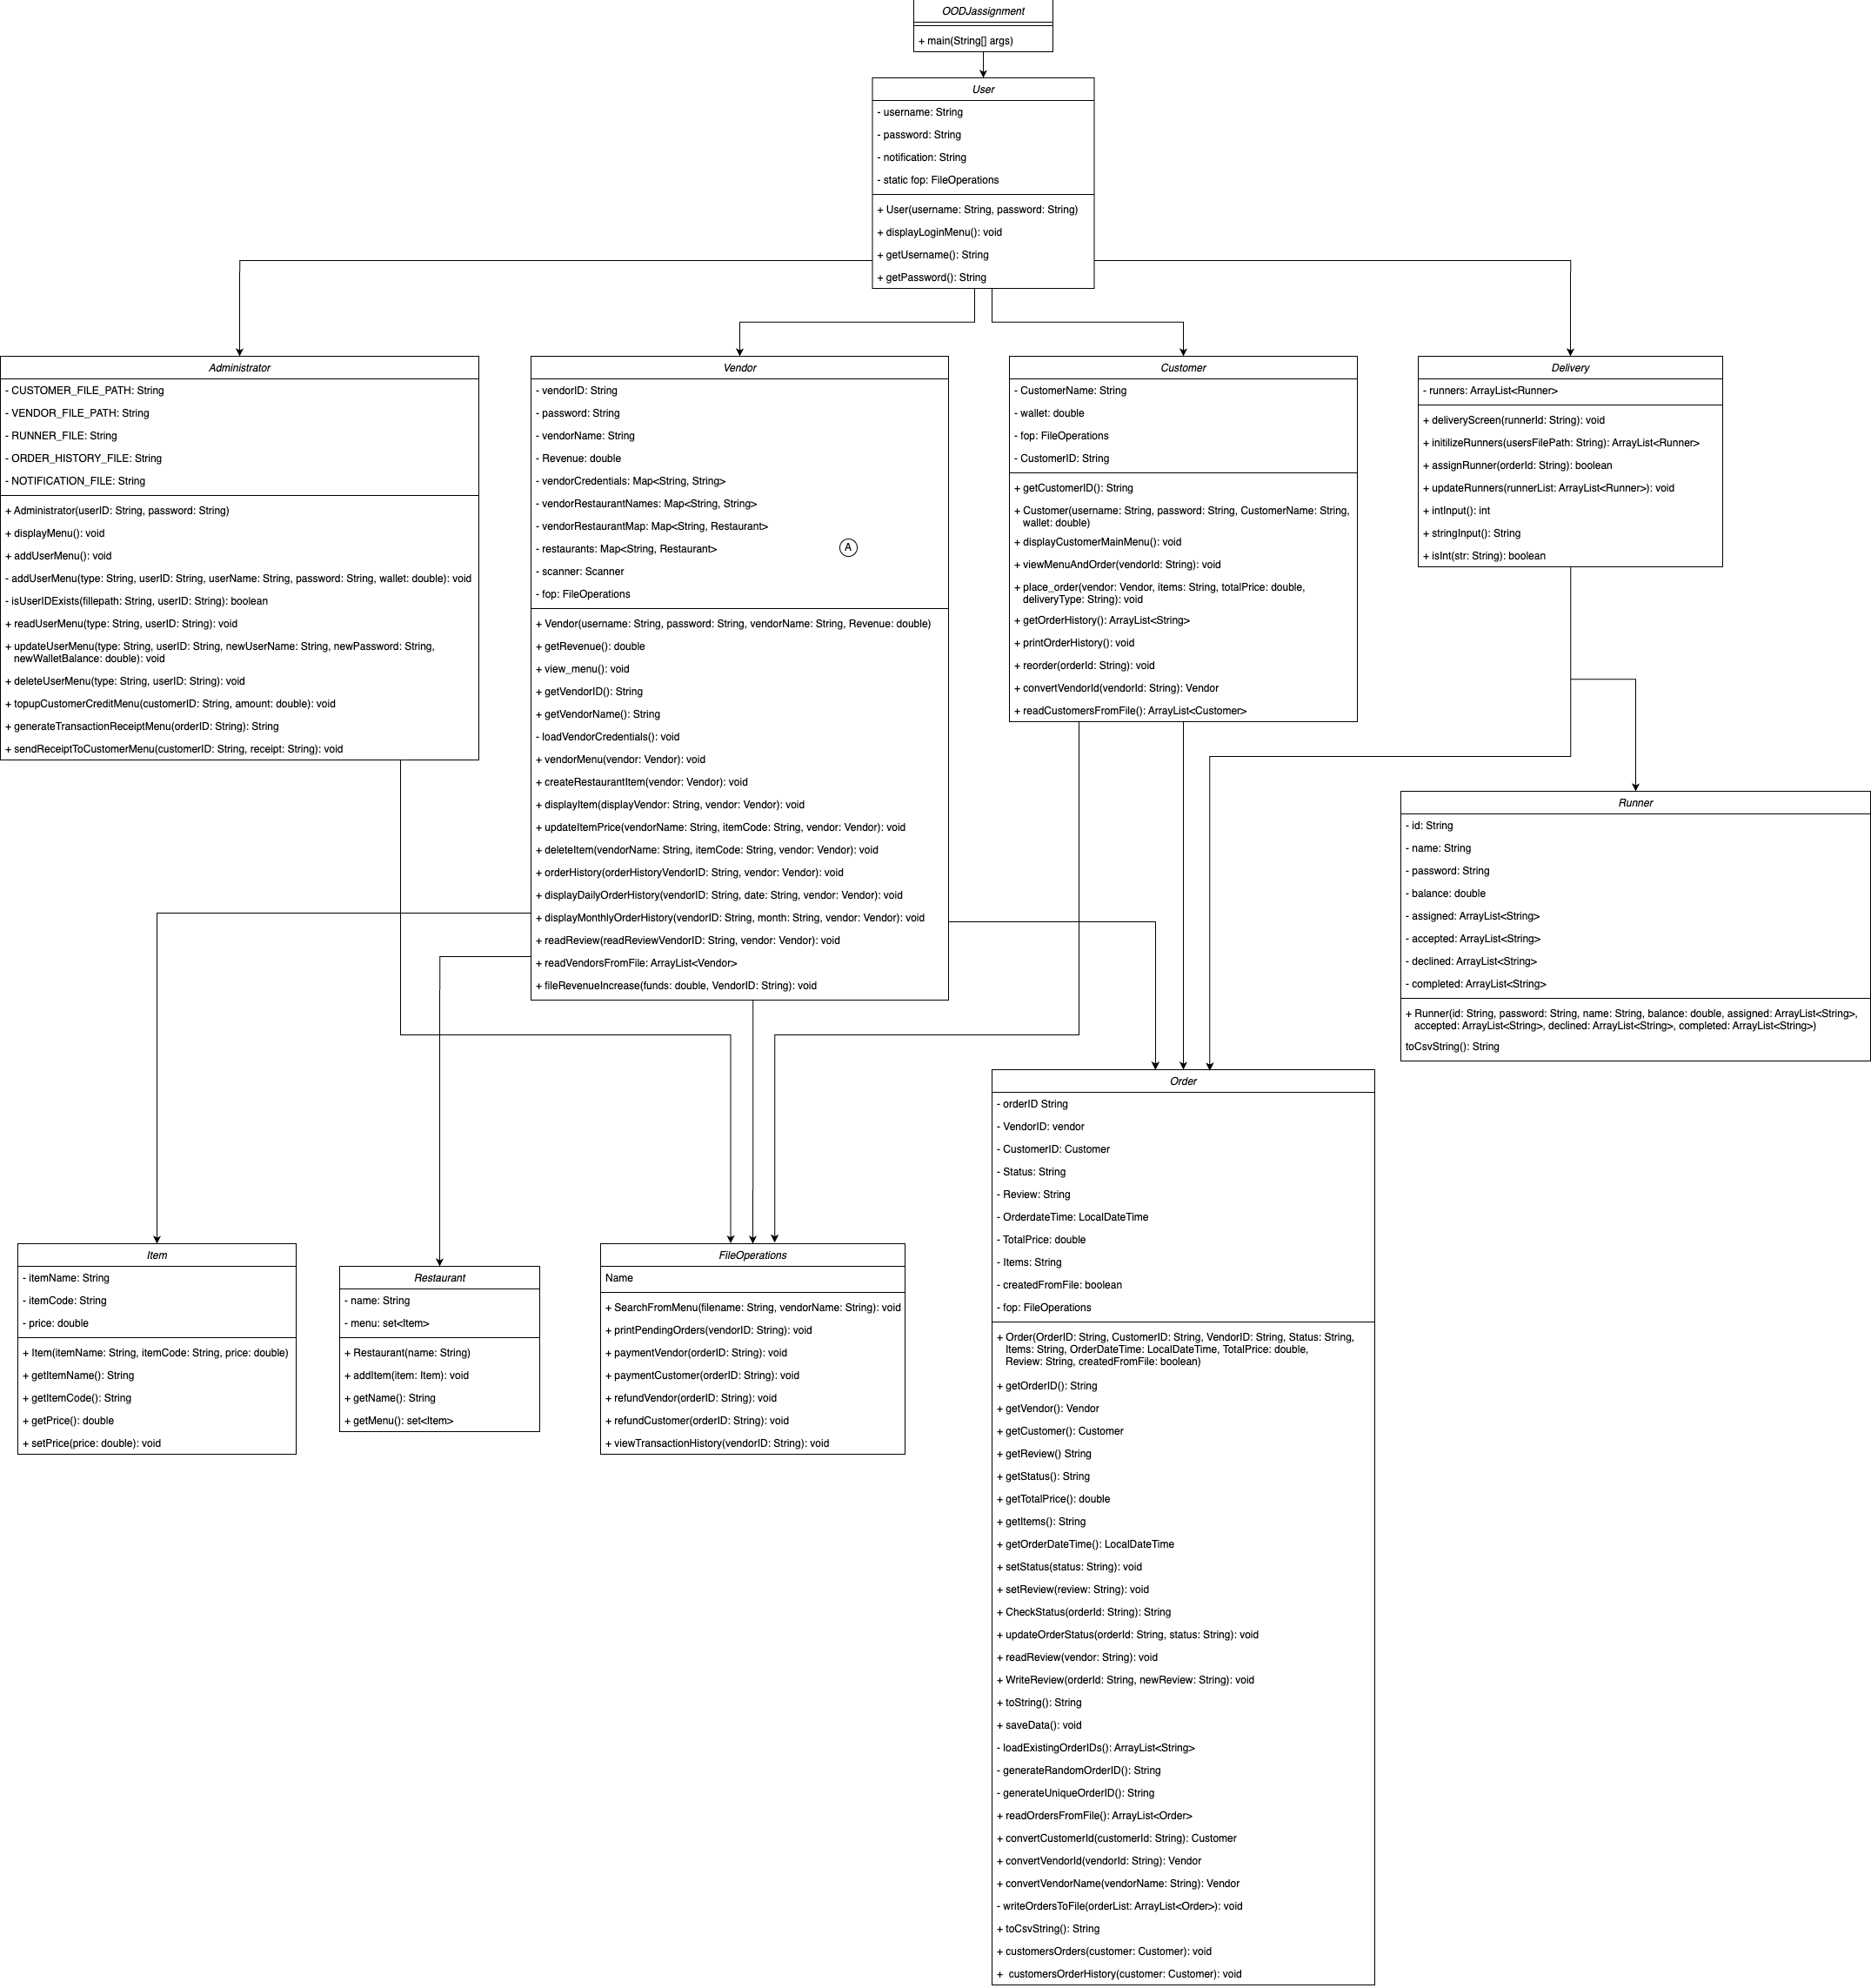

Figure 2.1.1: Whole Class Diagram

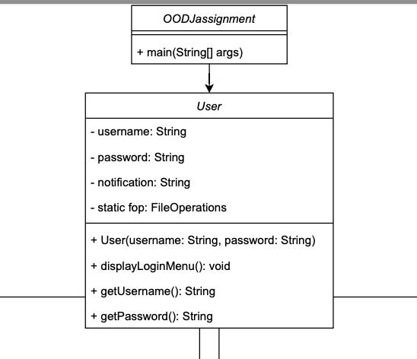

Figure 2.1.2: User (Zoomed In)

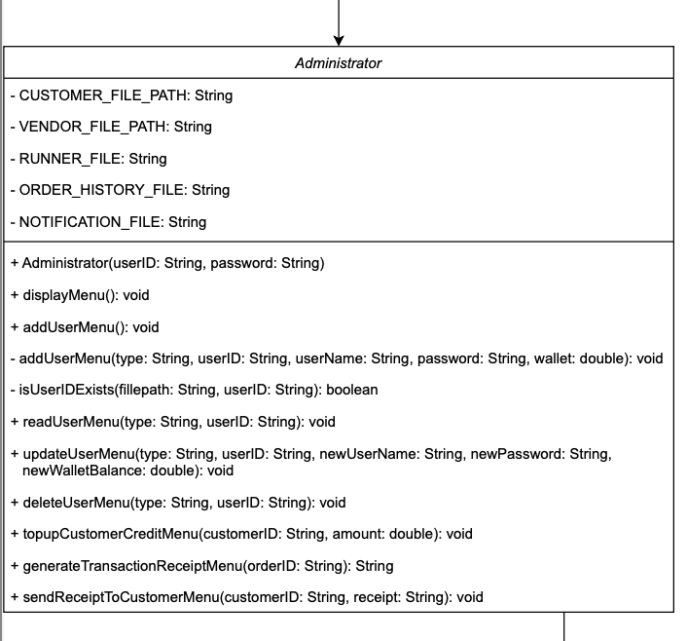

Figure 2.1.3: Administrator (Zoomed In)

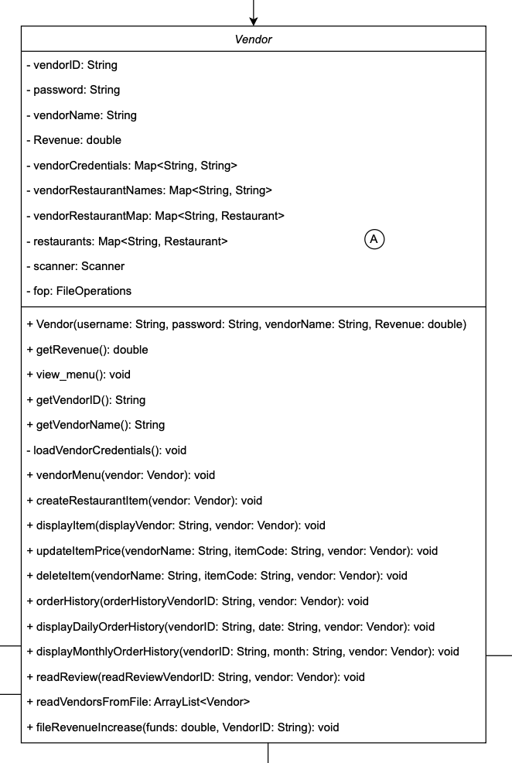

Figure 2.1.4: Vendor (Zoomed In)

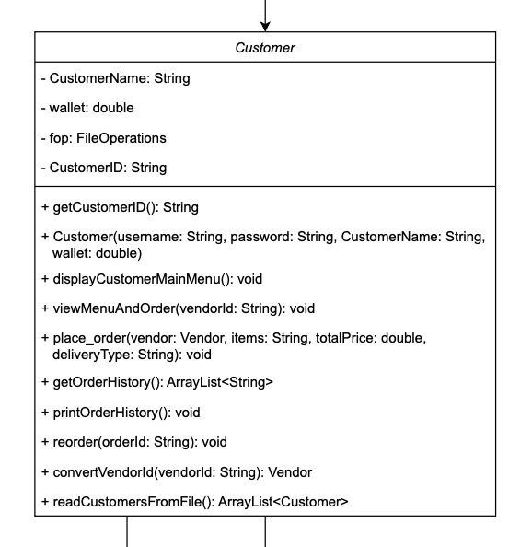

Figure 2.1.5: Customer (Zoomed In)

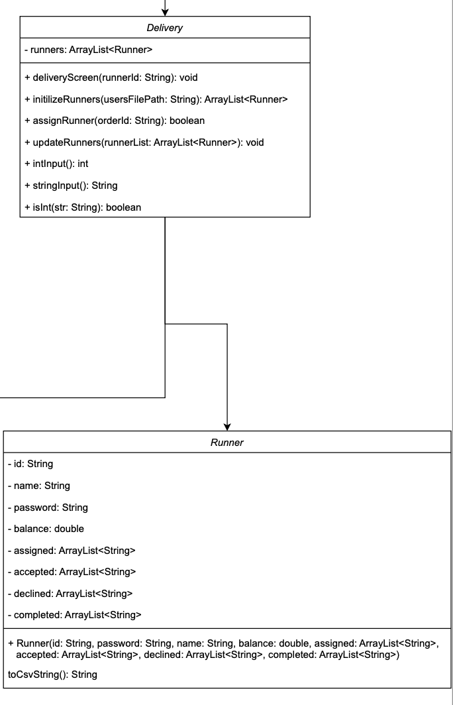

Figure 2.1.6: Delivery & Runner (Zoomed In)

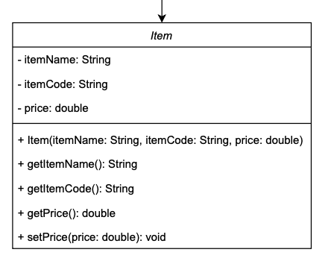

Figure 2.1.7: Item (Zoomed In)

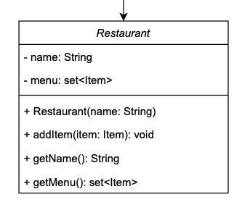

Figure 2.1.8: Restaurant (Zoomed In)

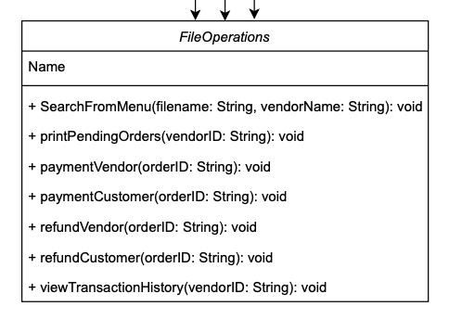

Figure 2.1.9: File Operations (Zoomed In)

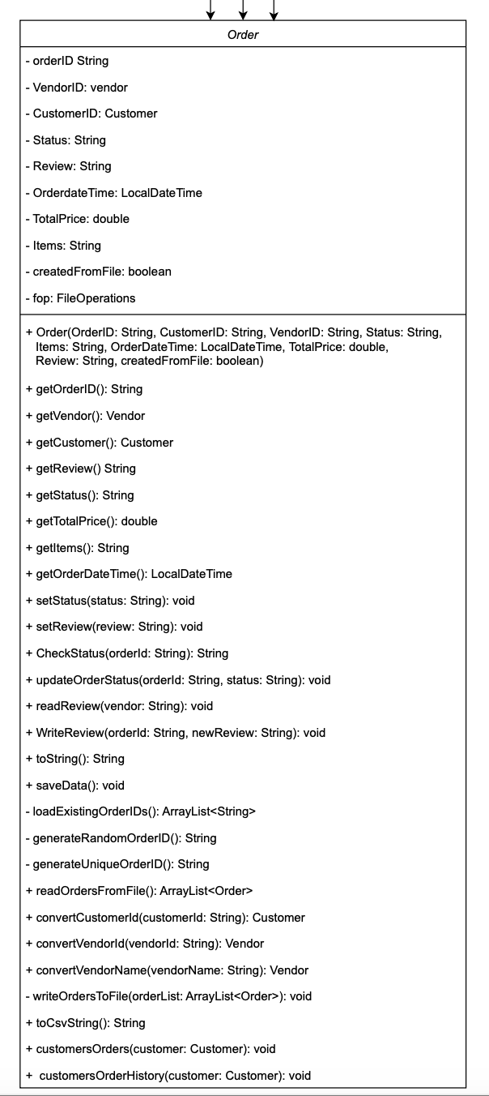

Figure 2.1.10: Order (Zoomed In)

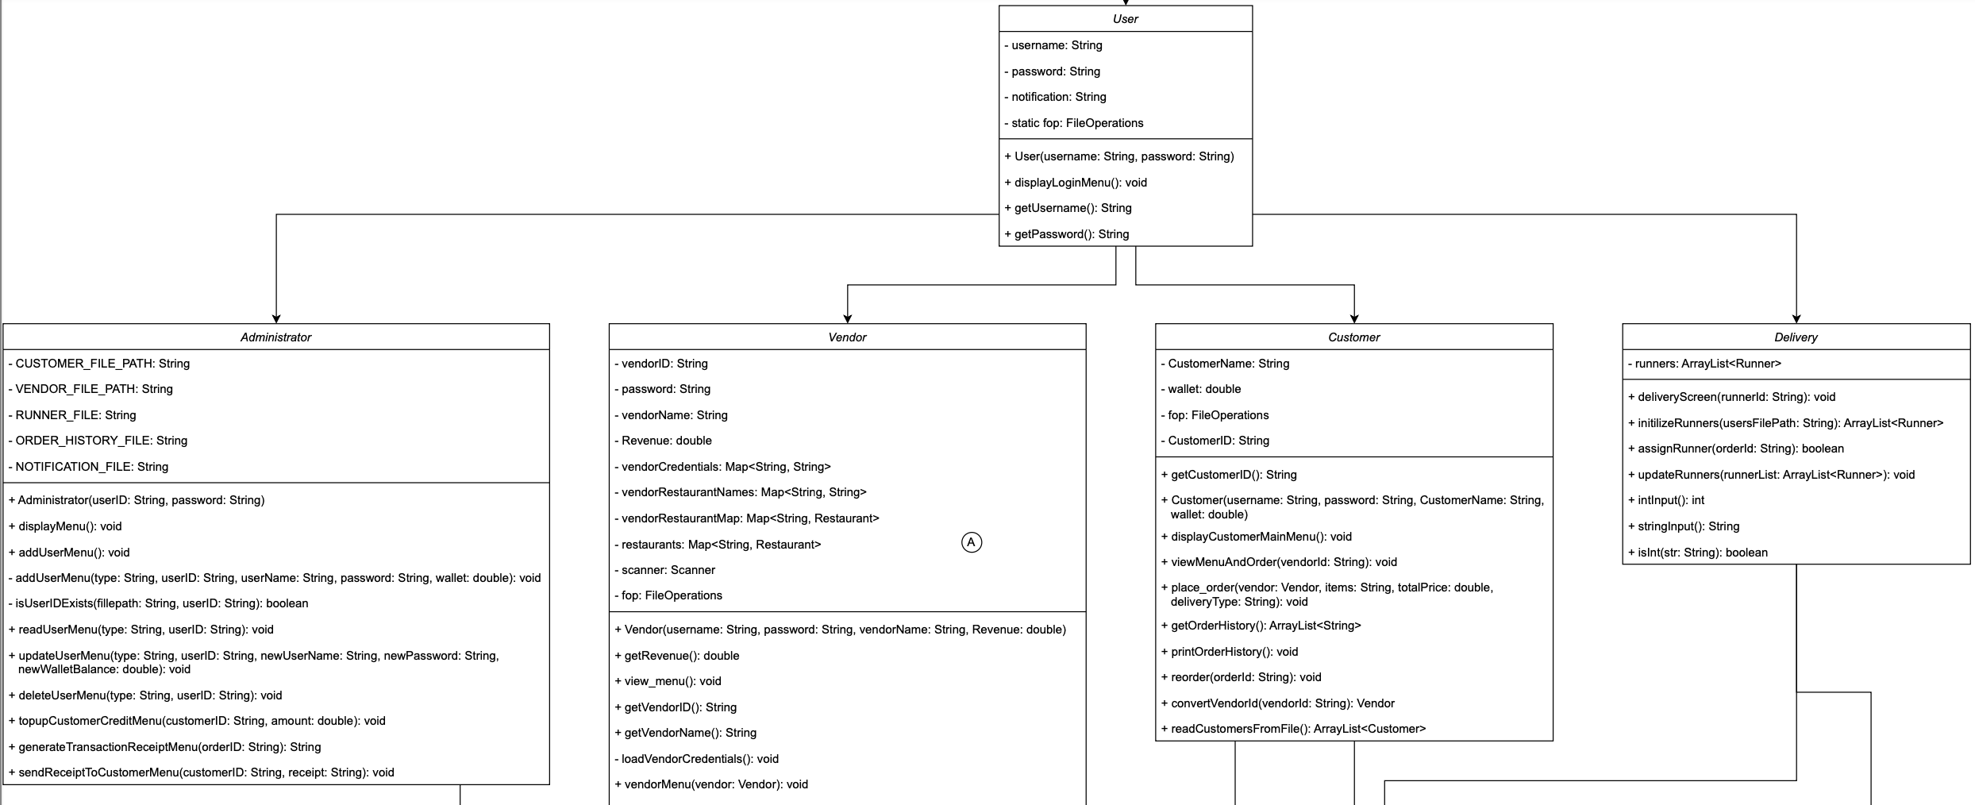

Figure 2.1.3: User to Administrator, Vendor, Customer, Delivery

## 2.2 UML Diagram

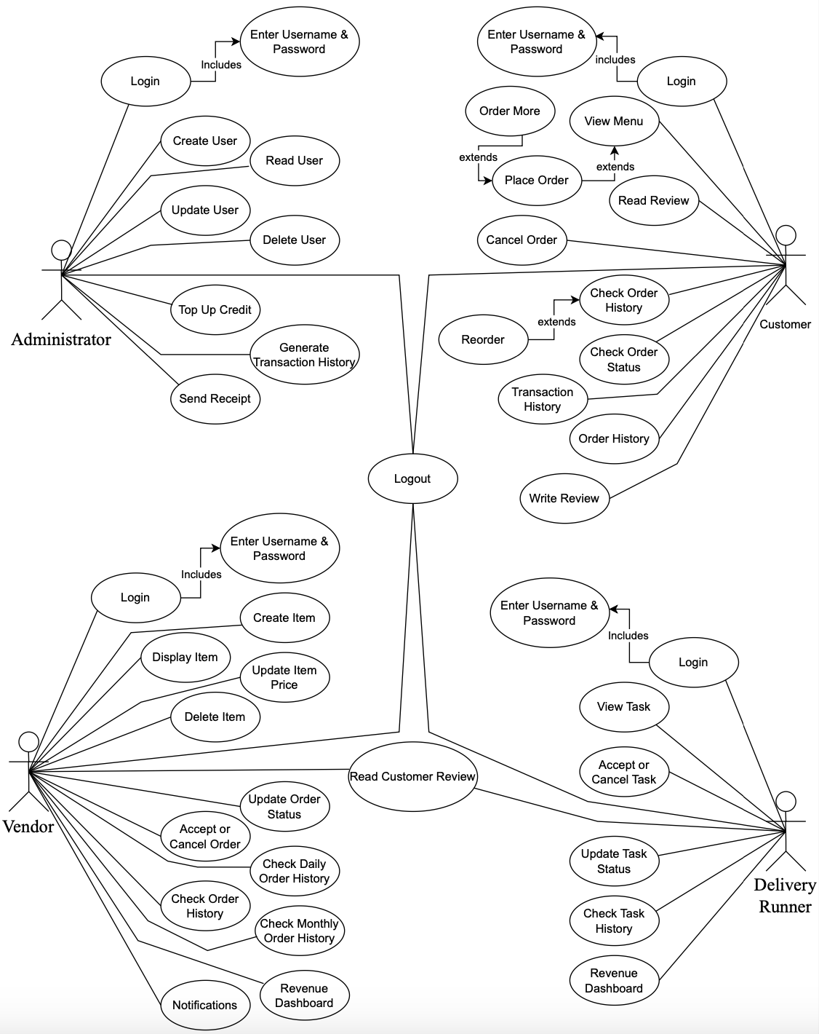

Figure 2.2.1: Whole UML Diagram

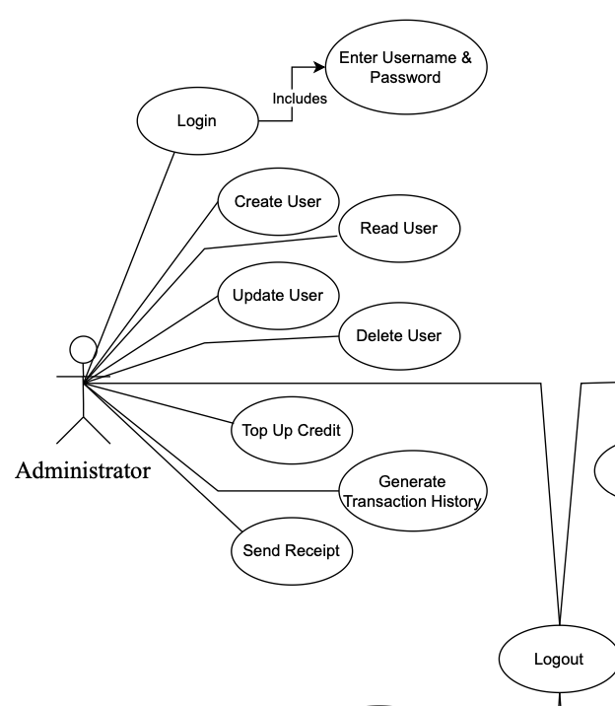

Figure 2.2.2: Administrator (Zoomed In)

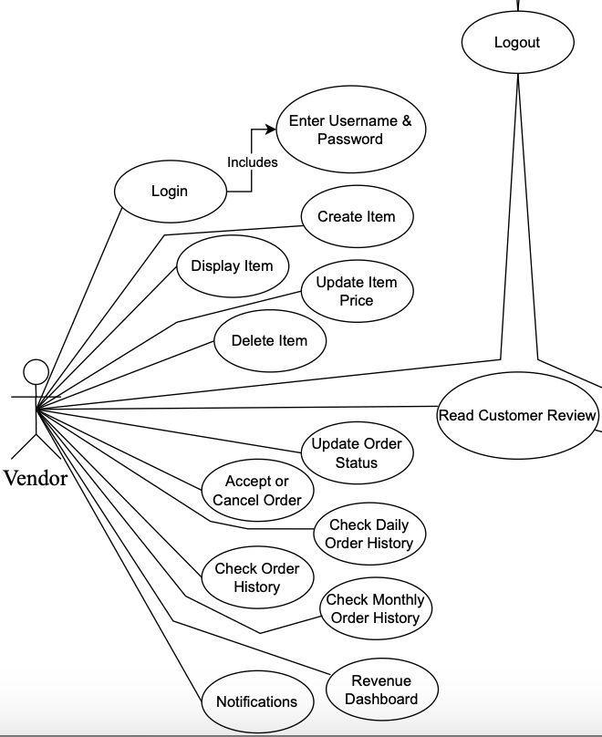

Figure 2.2.3: Vendor (Zoomed In)

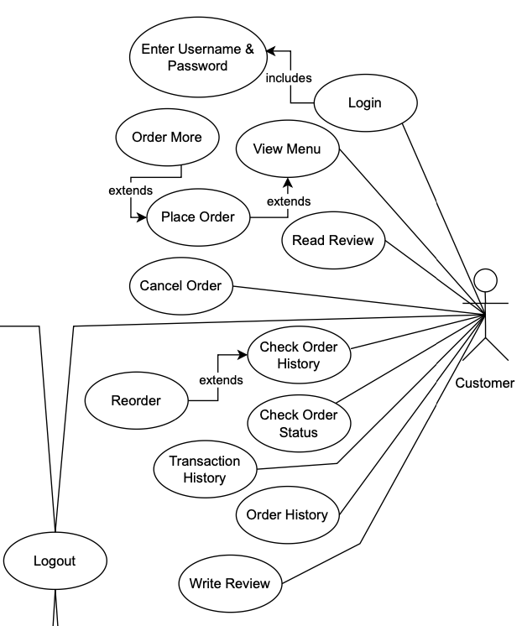

Figure 2.2.4: Customer (Zoomed In)

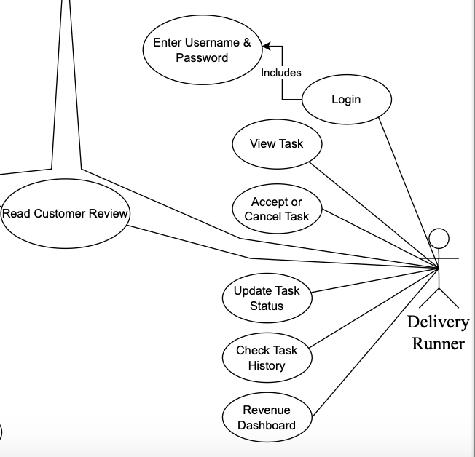

Figure 2.2.5: Delivery Runner (Zoomed In)

# 3.0 Screenshot of Output

Figure 3.1 is the output when we run the program. The program asks to choose a User type (Vendor type, Customer type, Delivery Runner type, Administrator type) to login or use more functionalities of it. Below is the figure:

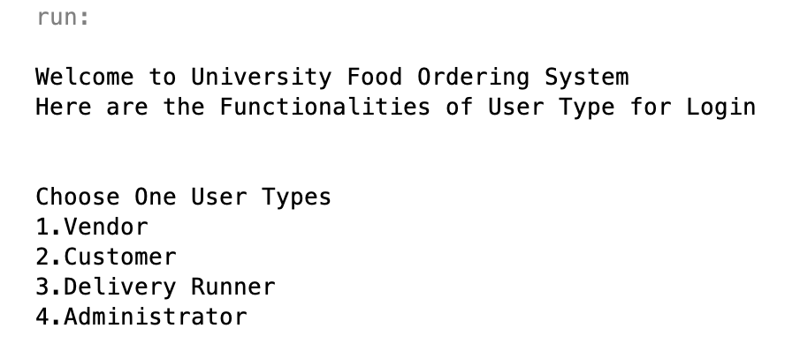

*Figure 3.1: Main Menu of University Food Ordering System*

## 3.1 Admin Part

### 3.1.1 Display Menu

First and foremost after login into the administrator account using the username and password, to collect information from the admin, the “displayMenu” technique displays an interactive menu. This approach makes use of a scanner.



*Figure 3.1.1.1*

In addition to actions connected to transaction receipts, customer credit, and sending notifications of the receipts to customers, the menu provides options for adding, reading, updating, and removing users.

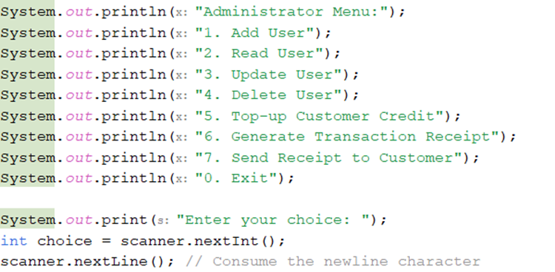

*Figure 3.1.1.2*

The menu is displayed with numbered alternatives, and each of these options indicates a specific activity that the administrator can carry out. The admin is requested to enter their choices after they have typed in the number that corresponds to the one given and then hit the "Enter" button. The software is informed by a switch statement about which method to use to carry out the operation that has been asked, and this decision is based on the admin’s selection. The "addUserMenu" function, for example, is activated when option 1 is selected. Option 2 is the path that leads to the "readUserMenu" technique, which is followed by options 3, 4, 5, 6, and 7. The selection that the user has made is stored in the choice variable.

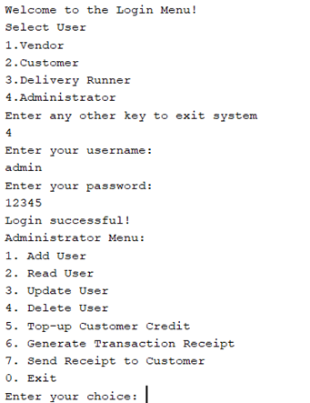

*Figure 3.1.1.3*

If the user chooses the value 0, the process will return, so breaking the loop. Additionally, the application will print a message stating that the administrator is exiting the menu.

The while (true) loop that it enters indicates that the menu will continue to appear until the user chooses to leave (enter 0), which is evidenced by the fact that it enters the loop.

In the event that the user makes a mistaken selection, which is a number that does not correspond to any operation, the software will notify the user and continue to perform the loop.

### 3.1.2 Add User Function

In order to activate the "Add User" feature, the administrator must first press the 1 button on the administrator menu. The administrator will have the ability to choose the type of user before initiating the process of adding a new user. In the event that the administrator presses 1 and 2, respectively, the user will be added under the customer, vendor, and runner categories. A user will be added to the runner list if the administrator presses the number 3. After selecting the user type, user ID, username, and password, it will then indicate to the administrator that they need to add the user. In addition to the information that is sought for the runner and the seller, the customer is also asked for the amount of money that is now in their wallet. In the end, it makes use of the information that was acquired in order to call the addUserMenu method. The filePath is determined by the type of user, which can be either a runner, a vendor, or a customer. It determines whether or whether the user already exists by utilizing the isUserIDExists method. The data of the user, including, if applicable, the amount of the wallet for customers, are appended to the file in the event that the user does not already exist.

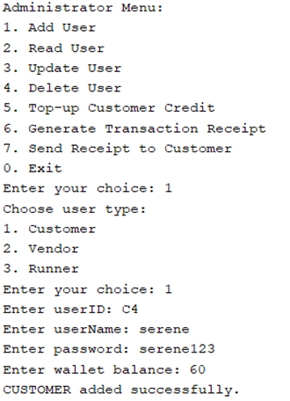 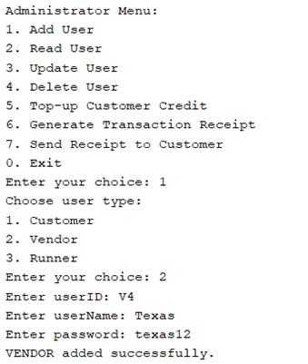

*Figure 3.1.2.1* *Figure 3.1.2.2*

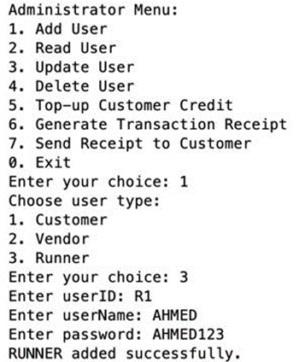

*Figure 3.1.2.3*

### 3.1.3 Read User Function

Admin can access the Read User function by selecting the second option from the Administration Menu. The function in question is responsible for reading information on users by the type of user used. To choose the type of user (runner, vendor, or customer), the administrator is given the option to enter either 1, 2, or 3 into the appropriate box. The “username” and “userID” are among the common pieces of information that are collected. Using the specific details (type, userID, and userName), this function retrieves the customer information from the file that is linked with the business. The “filePath” is determined by the type of user, which can be either a runner, a vendor, or a customer. If no user matches the user type, it will print a message stating that the user type was not discovered.

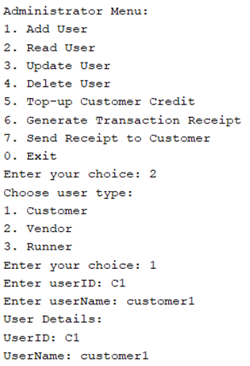 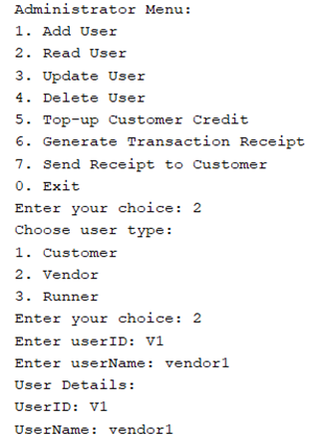

*Figure 3.1.3.1* *Figure 3.1.3.2*

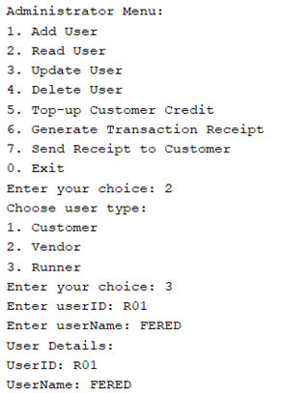

*Figure 3.1.3.3*

### 3.1.4 Update User Function

After that, updating user information in accordance with the “userID” and the kind of user selected. To choose the type of user (runner, vendor, or customer), the administrator is given the option to enter either 1, 2, or 3 into the appropriate box. For example, “userID”, “newUserName”, and “newPassword” are among the common pieces of information that are collected. In addition, it will collect a new Wallet Balance if the user type is "customer." After that, the “updateUserMenu” method is called, which is a function that takes parameters (userType, userID, newUserName, newPassword, and newWalletBalance). Utilizing the particular details (type, userID, newUserName, newPassword, and newWalletBalance), this function makes the necessary changes to the user information that is stored in the linked file. The “filePath” is determined by the type of user, which can be either a runner, a vendor, or a customer. BufferedReader is the tool that is utilized to read the contents of the file. If there are any users that have been updated, it will display a success message, but if the user type could not be located, it will print an error message.

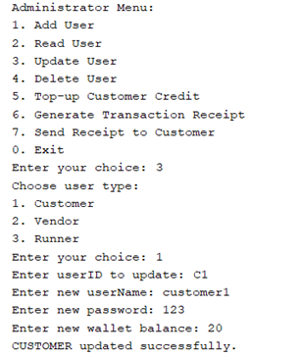 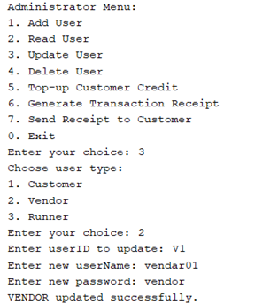

*Figure 3.1.4.1*  *Figure 3.1.4.2*

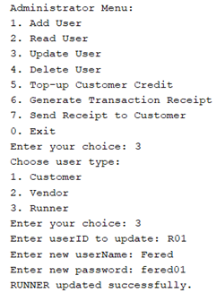

*Figure 3.1.4.3*

### 3.1.5 Delete User Function

It is the responsibility of the function that comes after it, “deleteUserMenu”, to remove a user from the menu. In a manner analogous to that of earlier jobs, it requests that the administrator choose the user type (runner, vendor, or customer) by entering the numbers 1, 2, or 3. After that, the “userID” of the individual whose account has to be deleted is gathered. Specifically, it makes use of the “deleteUserMenu” function, which takes two parameters: “userType” and “userID”. This method eliminates the user from the associated file by making use of the particulars (type, userID). The “filePath” is determined by the type of user, which can be either a runner, a vendor, or a customer. “BufferedReader” is the tool that is utilized in order to read the contents of the file. If there are any users that are removed, it will send out a message of success, and if the user type cannot be located, it will send out an error message.

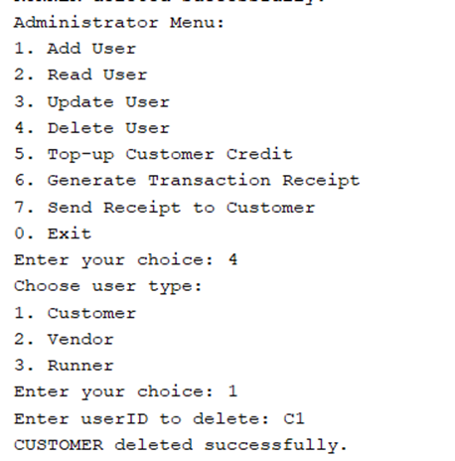 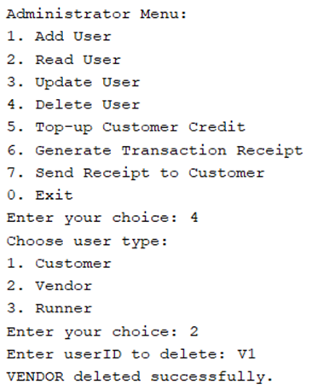

*Figure 3.1.5.1*  *Figure 3.1.5.2*

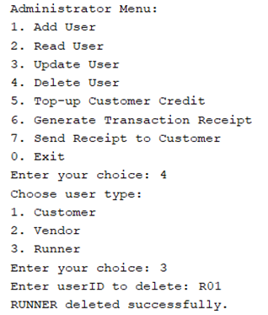

*Figure 3.1.5.3*

### 3.1.6 Top-up Customer Credit Function

The "topUpCustomerCreditMenu" function is the next one to be executed, and it is the job of this method to initiate the process of adding credit to consumers. There is a prompt that occurs whenever the administrator enters the customerID for whom additional credit is required. After that, the administrator is given the opportunity to enter the sum that needs to be added. Using the particulars (customerID, amount), this process makes adjustments to the credit that is linked with the customer in the specified file. It is the path of the customer file that is utilized as the filePath. A BufferedReader is utilized in order to retrieve the information from the client file. In the event that there is an update, it will print a message indicating that the customer could not be located, and if there is no update, it will publish a message

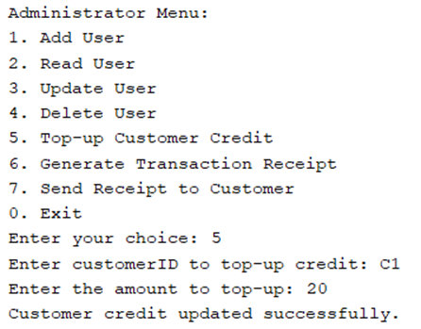

*Figure 3.1.6.1*

### 3.1.7 Generate Transaction Receipt Function

In addition, a transaction receipt can be generated by using the "generateTransactionReceiptMenu" method and specifying a "orderID" as the input. This function is the one that kicks off the process of creating a receipt for a transaction. To ensure that a receipt is generated, the administrator is required to enter the “orderID”. Through the utilization of the particulars (orderID), this method searches the order history file for an order that is a counterpart. The “filePath” component is where the path to the order history file is entered. Utilizing a “BufferedReader”, it retrieves the information from the file that contains the order history. In the process, it reads each line of the file exactly once. When it encounters a line that starts with the “orderID” that was provided, it determines that it has successfully located the order data that is associated with it.

The receipt is subsequently produced, most often with the type "OrderID, Details, Amount" for the transaction. In addition to this, it breaks down the order of details by using commas to divide them, and then it publishes each detail independently, which makes the information more organised and clearer. If the specified “orderID” cannot be found, it will print a notice stating that the receipt requested for that order could not be located.

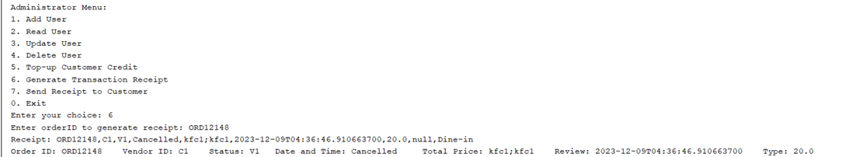

*Figure 3.1.7.1*

### 3.1.8 Send Receipt to Customer Function

The following one is the "sendReceiptToCustomerMenu" method, which is the entry point for providing a receipt to a customer who is receiving it. The administrator is informed that they are required to enter the "orderID" for which the receipt is to be delivered. Through the utilization of the particulars (orderID), this method searches the order history file for an order that is a counterpart. The “filePath” component is where the path to the order history file is entered. Utilizing a “BufferedReader”, it retrieves the information from the file that contains the order history. In the process, it reads each line of the file exactly once. When it encounters a line that starts with the “orderID” that was provided, it determines that it has successfully located the order data that is associated with it. Following the extraction of the “customerID” from the order information, the next step is to execute the second overloaded method by making use of the “customerID” and the receipt. The “customerID” and receipt are used in this operation to create a notification that is written to a file (perhaps a notification file). To keep things as straightforward as possible, it just adds a note to the notification file (NOTIFICATION_FILE) noting that a receipt has been successfully delivered to the client who provided their “customerID”.

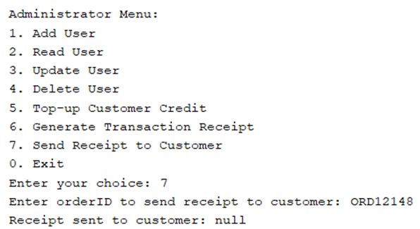

*Figure 3.1.8.1*

### 3.1.9 Exit Function

The entire process instantly exits using the return statement if the result of admin’s choice is 0. The console is then printed with the message "Exiting Administrator Menu." This gives you the ability to break out of the menu loop or leave the method whenever the user decides to do so. The default case is entered by “UserChoice” which is the admin in the event that its value, which in this instance is not zero, does not correspond to any of the situations that have been given. It displays the message "Invalid choice" in the typical circumstance. The console would appreciate it if you could enter a credible option." This is the method by which you communicate to the user that the input they provided is not valid.

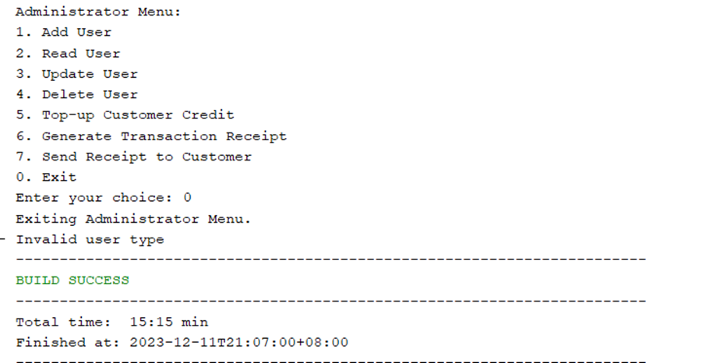

*Figure 3.1.9.1*

## 3.2 Vendor Part

### 3.2.1 Vendor Login

After run the program, system will ask to choose the user type. When we choose 1 which is Vendor, it goes to Vendor Login function and asks to login with the vendor credentials. If username & password are matched with the login credentials then it shows that login successful and display the Main Menu of Vendor Functionalities.

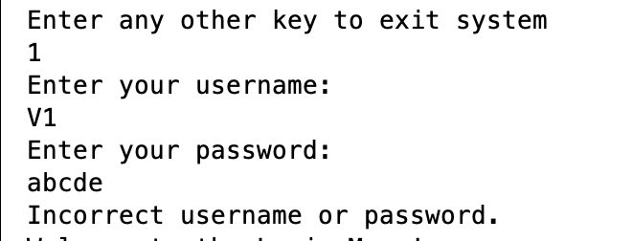

*Figure 3.2.1.1: Wrong Credentials*

The user will then be asked to enter their username and password. Entering the wrong username or password will print the statement “Incorrect username or password” and user will be taken back to the login menu.

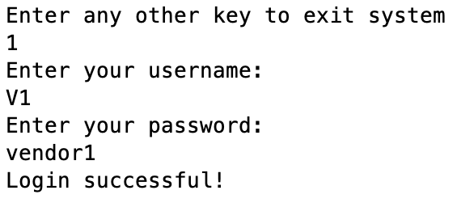

*Figure 3.2.1.2: Login to Vendor Functionalities with Correct Credentials*

Entering the correct username and password will take you to the Vendor main menu where Vendor can decide what they wish to do.

### 3.2.2 Main Menu

Figure 3.2.2.1 is the main menu of vendor functionalities. Here are the 12 options for vendor user type. The functions are Create Item, Display Item, Update Item, Delete Item, Accept or Cancel Order, Check Pending Orders, Check Order History, Check Daily Order History, Check Monthly Order History, Read Customer Review, Revenue Vendor Dashboard, Notifications, and the last one is Logout. Below is the figure of vendor menu:

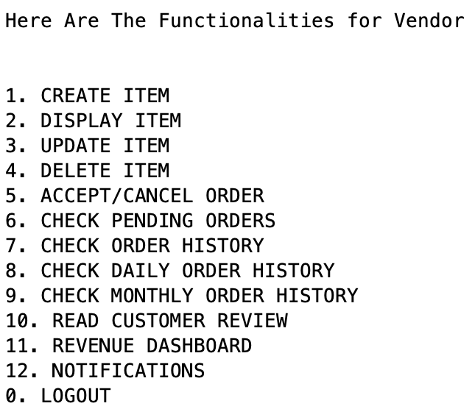

Figure 3.2.2.1: Menu for the Vendor Functionalities

### 3.2.3 Create Item

Figure 3.2.3.1 is the Create Item Function. When user choose 1, it goes to create item function, and asks the user to input the Item Code, Item Name, and Item Price. After input all the information, system will display that item created successfully.

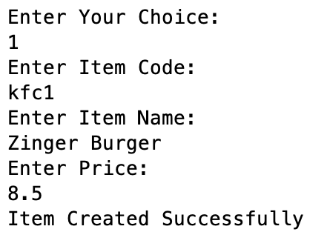

Figure 3.2.3.1: Create Item Function

### 3.2.4 Display Item

Figure 3.2.4.1 is the Display Item function. When user choose 2, it goes to create item function, and asks the user to input the Vendor ID to display their menu. After input the vendor ID, the system will display all the menu for this vendor.

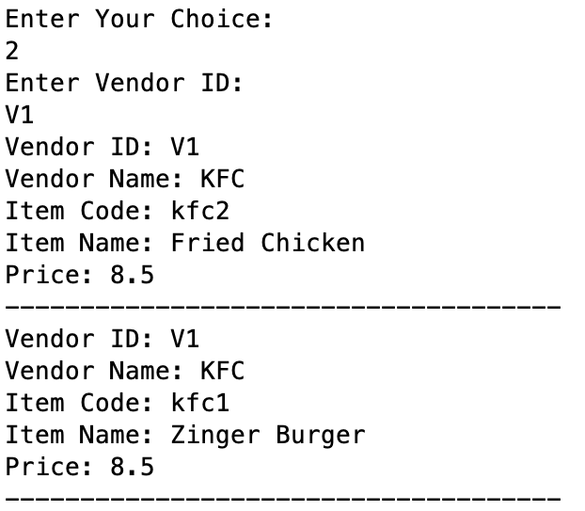

Figure 3.2.4.1: Display Item Function

### 3.2.5 Update Item

Figure 3.2.5.1 is the Update Item function. When user choose 3, it goes to update item function, and asks the user to input the restaurant name. If the restaurant name is found in the file it asks to enter the item code. If the item code is found for that restaurant, it asks to enter the new price. After enter the new price, system will display that Price Updated Successfully.

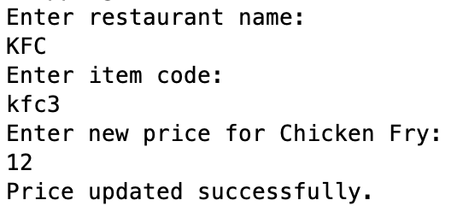

Figure 3.2.5.1: Update Item Function

### 3.2.6 Delete Item

Figure 3.2.6.1 is the Delete Item function. When we choose 4, it goes to delete item function, and asks the user to input the restaurant name. If the restaurant name is found in the file it asks to enter the item code. If the item code is found for that restaurant, it will delete that item for that restaurant and display that Item found and deleted.

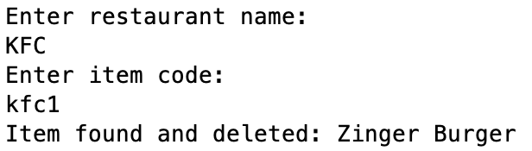

Figure 3.2.6.1: Delete Item Function

### 3.2.7 Accept Pending Order

Figure 3.2.7.1 & 3.2.8.1 is the Accept or Cancel Order Function. When we choose 5, it goes to accept or cancel order function and ask to enter accept pending order or cancel order option. If choose accept pending order, it will display all the order which are pending in that moment and asks to enter the order ID to accept the order. After enter the order ID, it will accept the order also funds have been transfer to vendor account and display that Order Status Updated Successfully & Order accepted! Funds have been added to vendor revenue.

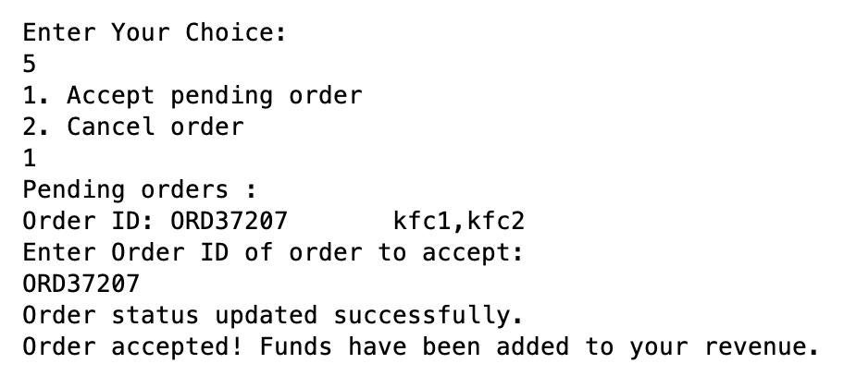

Figure 3.2.7.1: Accept Order Function

### 3.2.8 Cancel Order

After choose 5, when we choose cancel option, it will display all the accepted order ID to cancel the order and asks to enter the order ID for cancel. After enter the order ID, it will cancel the order also funds have been transfer to customer account and display that Order Status Updated Successfully & Order cancelled successfully! Funds have been refunded to customer wallet.

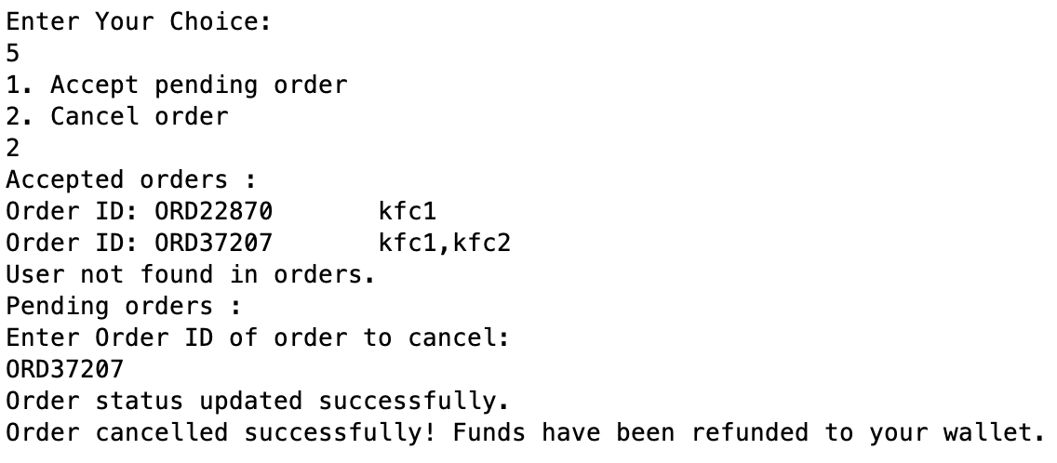

Figure 3.2.8.1: Cancel Order Function

### 3.2.9 Check Pending Orders

Figure 3.2.9.1 is the check pending orders function. When we choose 6, it will display all the pending orders that are pending in that moment.

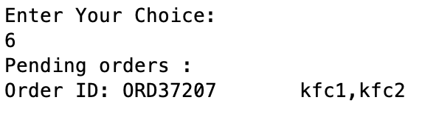

Figure 3.2.9.1: Check Pending Order Function

### 3.2.10 Check Order History

Figure 3.2.10.1 is the check order history function. When we choose 7, the system will automatically read the vendor ID that are logged in and read the vendor ID from the file, then it will display all the order History for the vendor.

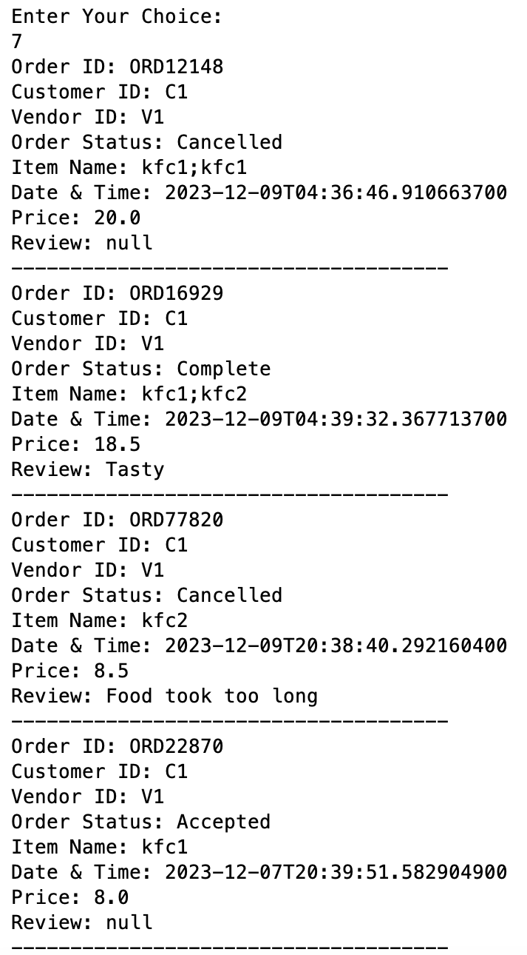

Figure 3.2.10.1: Check Order History Function

### 3.2.11 Check Daily Order History

Figure 3.2.11.1 is the check daily order history function. When we choose 8, the system will automatically read the vendor ID that are logged in and read the vendor ID from the file, then it asks to enter the date that vendor wants to display. After enter the date, it will display all the order History for this given date of this vendor.

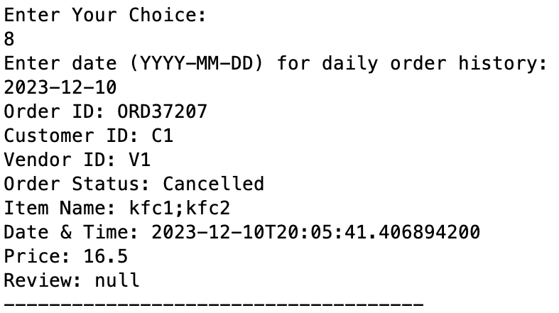

Figure 3.2.11.1: Check Daily Order History Function

### 3.2.12 Check Monthly Order History

Figure 3.2.12.1 is the check monthly order history function. When we choose 9, the system will automatically read the vendor ID that are logged in and read the vendor ID from the file, then it asks to enter the month that vendor wants to display. After enter the month, it will display all the order History for this given month of this vendor.

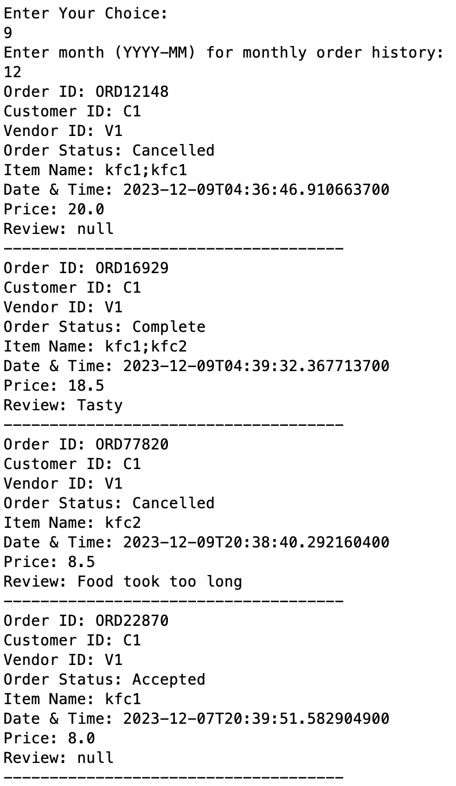

Figure 3.2.12.1: Check Monthly Order History Function

### 3.2.13 Read Customer Review

Figure 3.2.13.1 is the read customer review function. When we choose 10, the system automatically read the vendor ID from the file that are logged in, and display all the review for that Vendor.

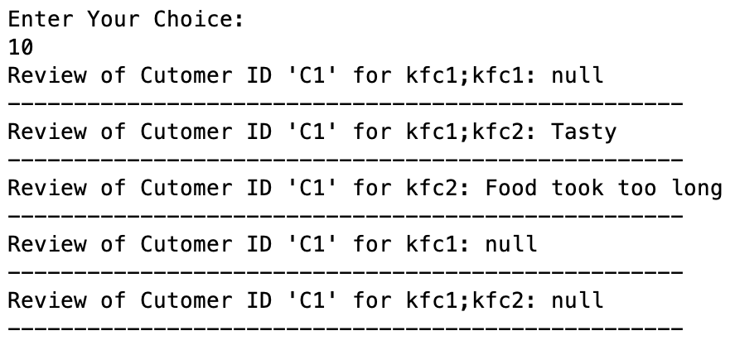

Figure 3.2.13.1: Read Customer Review Function

### 3.2.14 Revenue Dashboard

Figure 3.2.14.1 is the revenue vendor dashboard function. When we choose 11, it goes to vendor revenue function, and read the vendor ID automatically from the file that are logged in, and then it will display the revenue for this vendor.

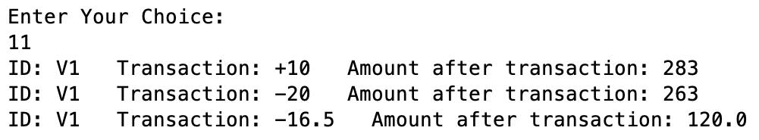

Figure 3.2.14.1: Revenue Dashboard Function

### 3.2.15 Notifications

Figure 3.2.15.1 is the notifications function. When we choose 12, it goes to notifications function and display all the notification that are not viewed before and display that would you like to remove a notification? If yes then choose 1, and if no then choose any other key. After choose 1, it asks to enter the notification number that vendor wants to remove, and when the notification number entered successfully it will removed that notification and display that Notification cleared successfully. If choose any other key to don’t remove notification, it will go back and display the vendor menu.

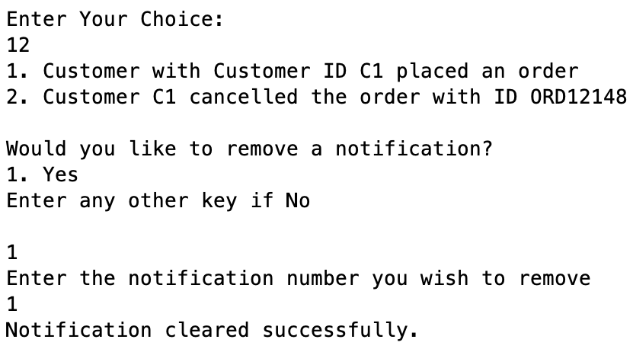

Figure 3.2.15.1: Notifications Function

### 3.2.16 Logout

Figure 3.2.16.1 is the logout function for vendor. When we choose 0 or any other key except 1 to 12, the vendor account will be logout and display the University Food Ordering System main menu.

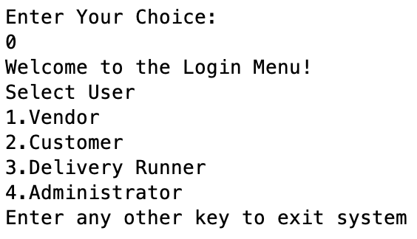

Figure 3.2.16.1: Logout Function

## 3.3 Customer Part

### 3.3.1 Files used in Customer class

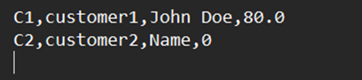

*Figure 3.3.1.1*

This a screenshot of the text file “CustomerData.txt” and it contains the customer credentials. It is in the format Customer ID, Customer password, Customer name, Customer wallet.

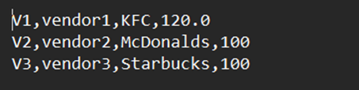

*Figure 3.3.1.2*

This a screenshot of the text file “VendorData.txt” and it contains the vendor credentials. It is in the format Vendor ID, Vendor password, Vendor name, Vendor revenue.

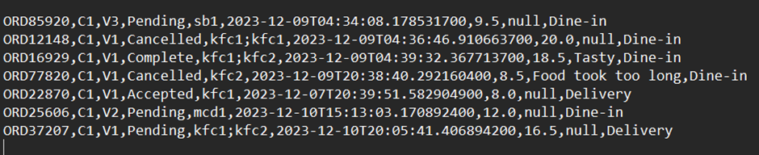

*Figure 3.3.1.3*

This is a screenshot of the text file “OrderHistory.txt” and it contains the order history details. It is in the format Order ID, Customer ID, Vendor ID, Order status, Item list, Date and time, Total price, Review, Delivery or Dine-in

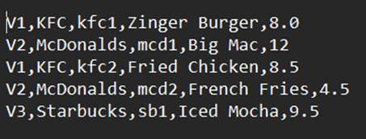

*Figure 3.3.1.4*

This is a screenshot of the text file “Menu.txt” and it contains the menu of all the vendors. It is in the format Vendor ID, Vendor name, Item ID, Item name, Item price.

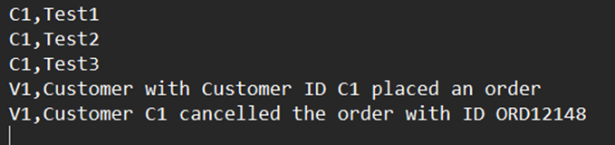

*Figure 3.3.1.5*

This is a screenshot of the text file “Notifications.txt” and it contains the notification details. It is in the format User ID, Notification.

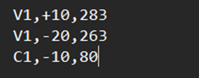

*Figure 3.3.1.6*

This is a screenshot of the text file “TransactionHistory.txt” and it contains the transaction details. It is in the format User ID, Transaction, Amount after transaction

### 3.3.2 Customer logging in

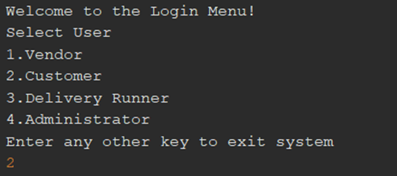

*Figure 3.3.2.1*

When the program is run, user is asked to enter a value corresponding to their user type. In the case for customer, enter 2.

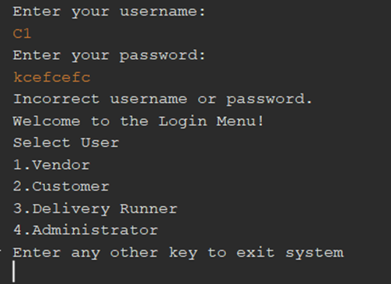

*Figure 3.3.2.2*

The user will then be asked to enter their username and password. Entering the wrong username or password will print the statement “Incorrect username or password” and user will be taken back to the login menu.

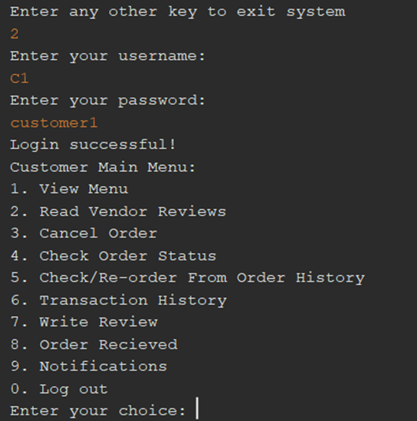

*Figure 3.3.2.3*

Entering the correct username and password will take you to the customer main menu where customer can decide what they wish to do.

### 3.3.3 View Menu

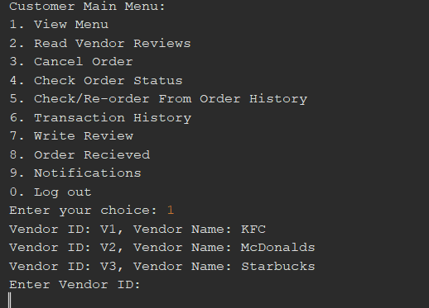

*Figure 3.3.3.1*

Entering choice 1 will display vendors customers can choose from to view their menu.

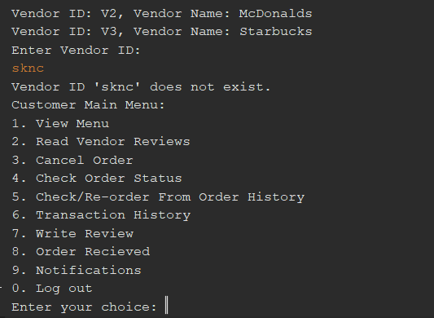

*Figure 3.3.3.2*

Entering an invalid Vendor ID will give the message that the vendor ID does not exist and redirect customer to the customer menu.

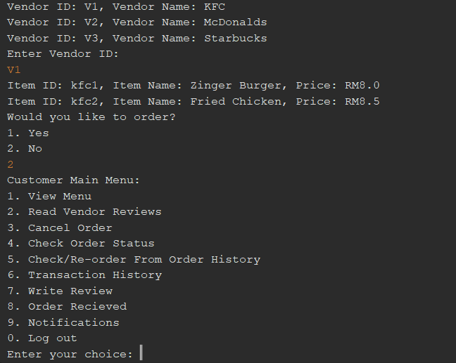

*Figure 3.3.3.3*

Entering a valid Vendor ID will display a list of all available items on the menu and then ask the customer if they would like to order. If customer chooses the No option, they will be redirected to the customer main menu.

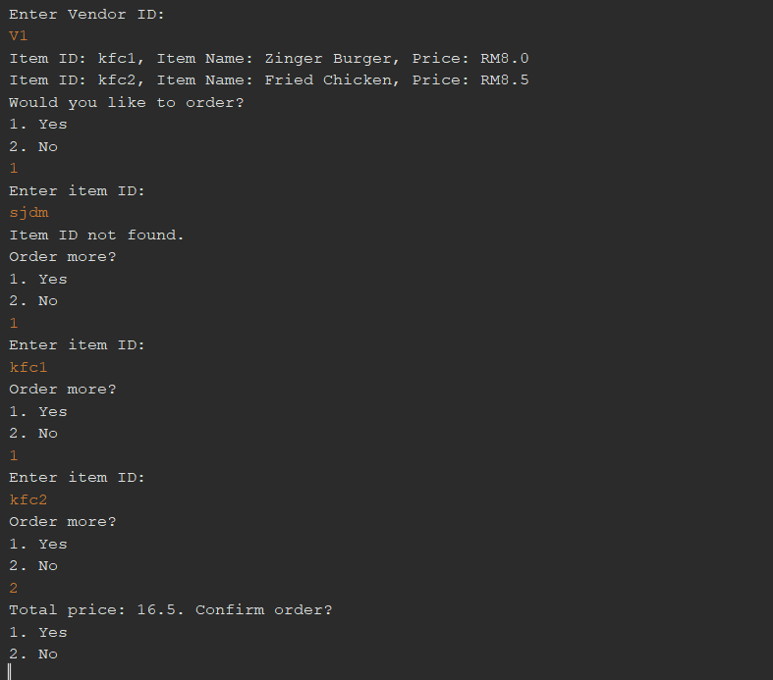

*Figure 3.3.3.4*

Entering the Yes option to “Would you like to order?” will ask customers to enter the Item ID of the item the wish to order. Entering an invalid item ID will tell the customer that Item ID is not found and ask if they wish to order more. When they do order an item with a valid Item ID, it will be added to cart and will ask if customer wants to order more. This will repeat until the customer says they don’t want to order anymore, and it will display the total price of the order.

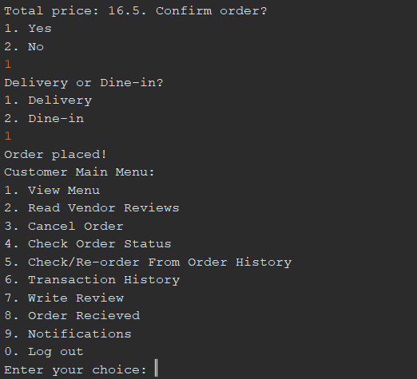

*Figure 3.3.3.5*

Once user confirms their order, they will be asked if they want delivery or dine-in. After user selects one of the two options, the order will be placed, and the customer will be redirected to the customer main menu.

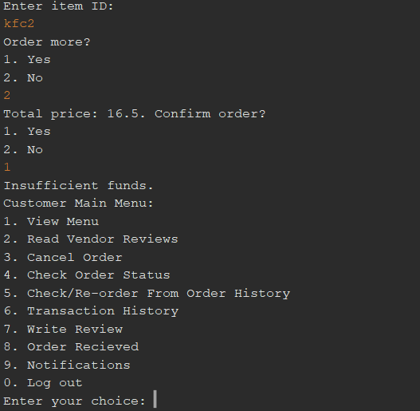

*Figure 3.3.3.6*

If customer does not have enough funds in their wallet, a message of “Insufficient funds” will be sent and the customer will be redirected to customer main menu.

### 3.3.4 Read Vendor Reviews

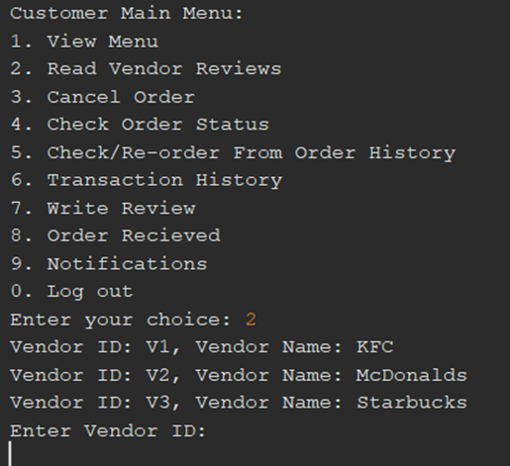

*Figure 3.3.4.1*

Enter option 2 to read the reviews of a vendor. It prompts customer to enter Vendor ID of the vendor the want to read views of.

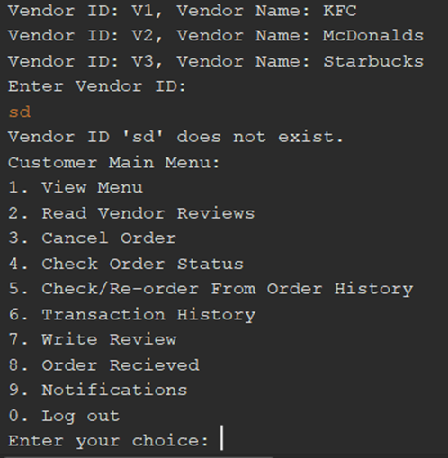

*Figure 3.3.4.2*

Entering incorrect Vendor ID will let the customer know that the vendor ID does not exist and brings customer back to main menu.

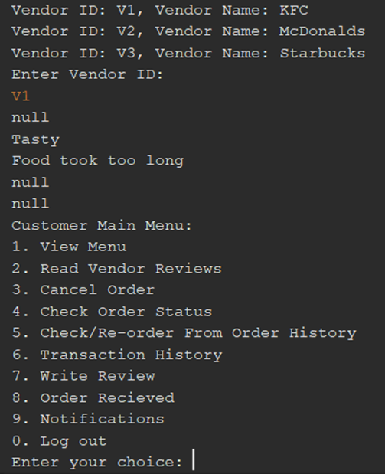

*Figure 3.3.4.3*

Entering a correct Vendor ID will print out all the reviews received by that vendor. After that, customer is redirected back to customer main menu.

### 3.3.5 Cancel Order

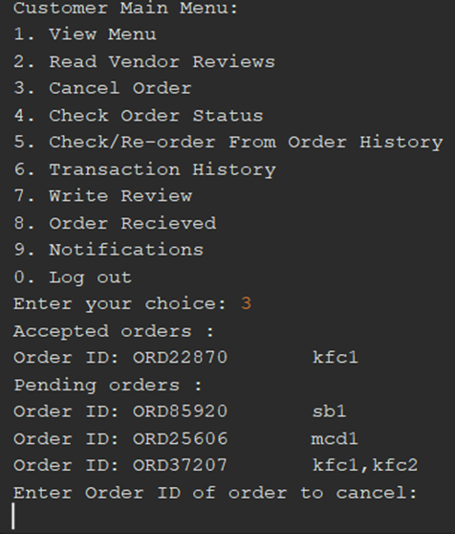

*Figure 3.3.5.1*

Enter option 3 if customer wishes to cancel an order. First, all the pending orders and accepted orders by vendors will be displayed to the customer along with Item ID. Customer is asked to enter the Order ID of the order they wish to cancel.

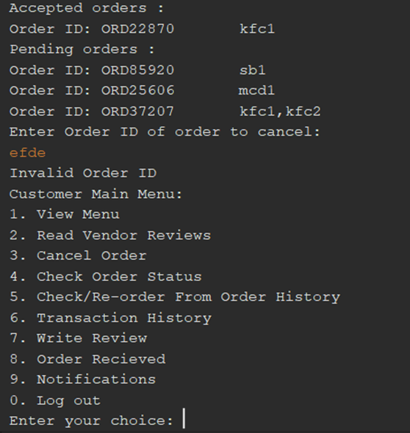

*Figure 3.3.5.2*

Entering invalid Order ID lets the customer know that it is invalid and takes them back to the customer main menu.

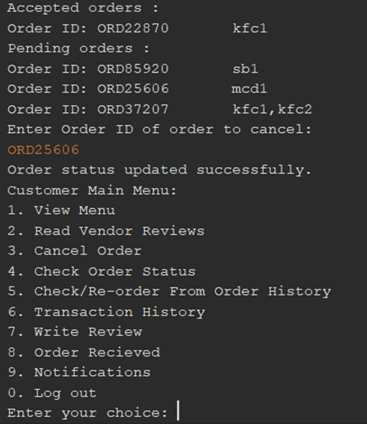

*Figure 3.3.5.3*

Entering a valid Order ID will get the message saying that the Order status in updated and will be written in the order history as cancelled. Moreover, orders with “Accepted” status before being cancelled will refund the customer and deduct it from the vendor revenue as orders with “Accepted” status has its payment complete. After this, customer will be directed to customer main menu once again.

### 3.3.6 Check Order Status

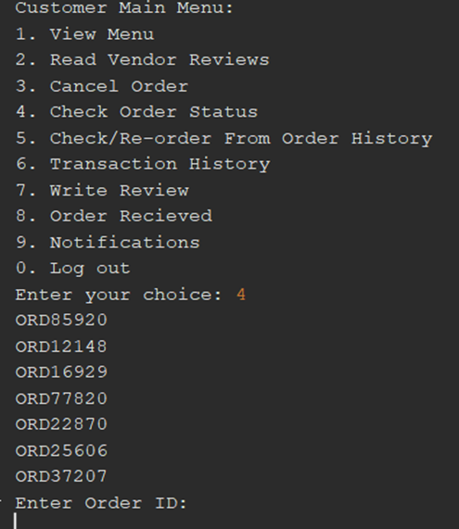

*Figure 3.3.6.1*

Entering option 4 will prompt customer to enter Order ID of the order that the customer wishes to check status of.

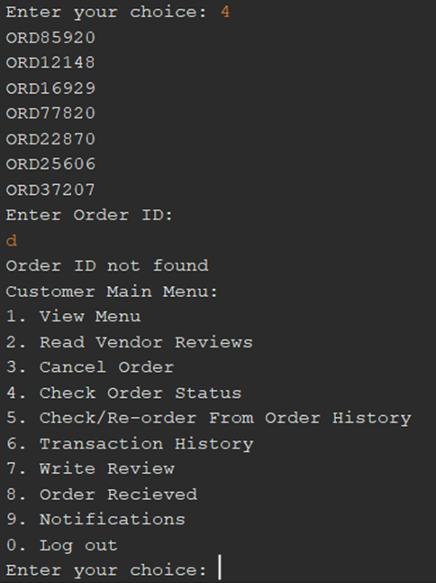

*Figure 3.3.6.2*

Entering invalid Order ID will give a message that Order ID is not found and customer is redirected to the main menu page.

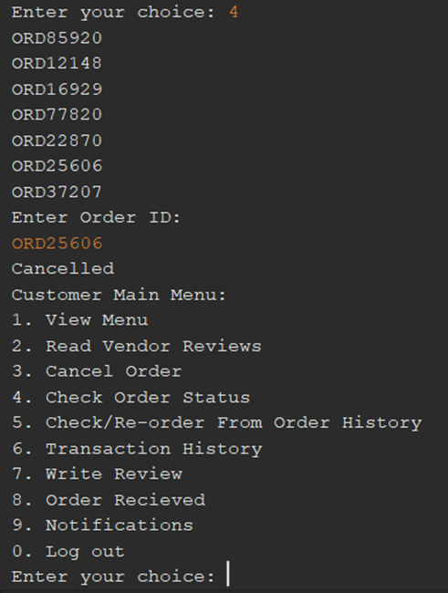

*Figure 3.3.6.3*

Entering a valid Order ID will print the status of that order. ORD25606 is the order that was cancelled in Figure 3.3.21

Check/Re-order From Order History

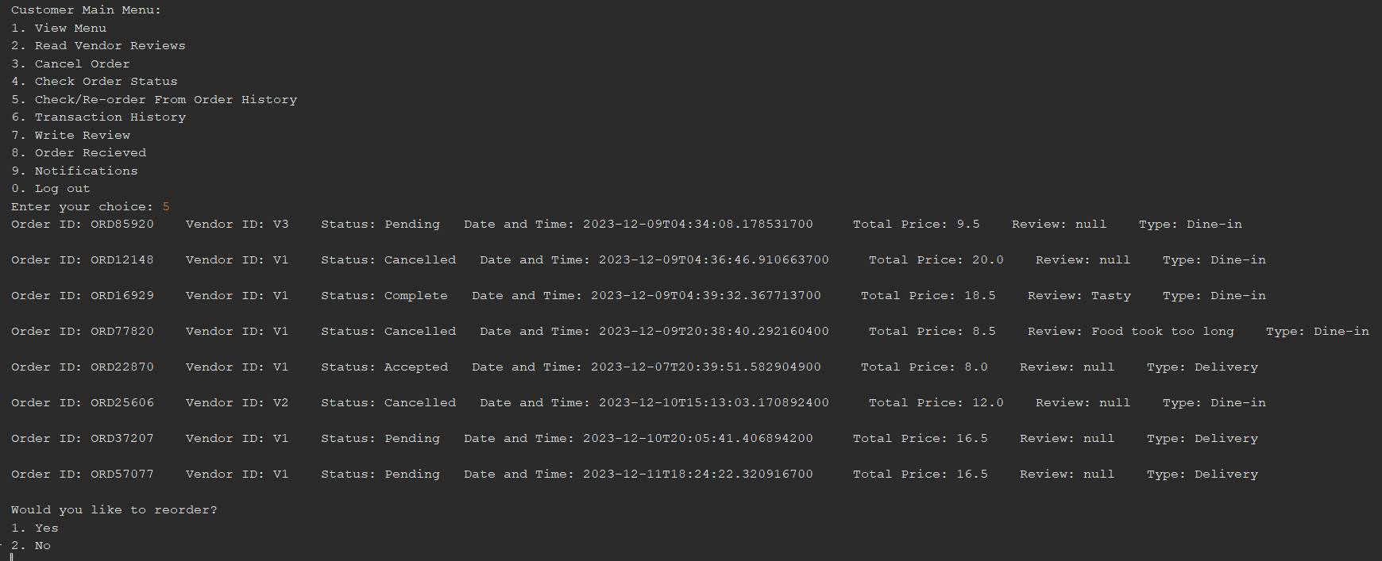

*Figure 3.3.6.4*

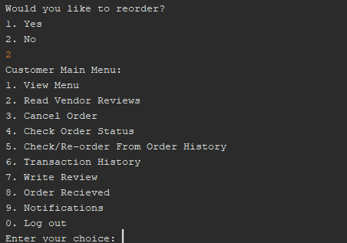

*Figure 3.3.6.5*

Entering choice 5 will display the order history of that customer and then ask the customer if they wish to re-order. Choosing the option No will redirect the customer to the customer main menu.

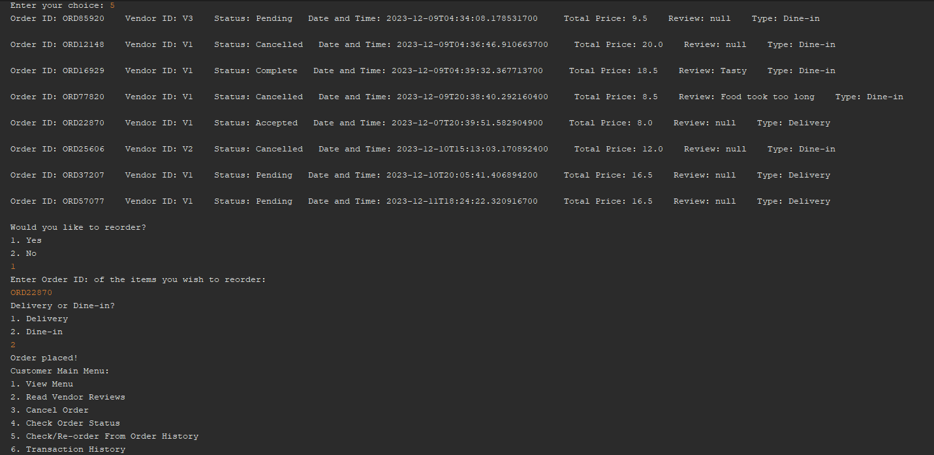

*Figure 3.3.6.6*

Entering the option 1 for re-ordering will ask customer to enter the Order ID of the order they wish to re-order. Once they enter the Order ID, they will be asked if they want it to be delivered or to have it dine-in. Once customer selects the option, order will be placed, and customer will be redirected to the customer main menu.

### 3.3.7 Transaction History

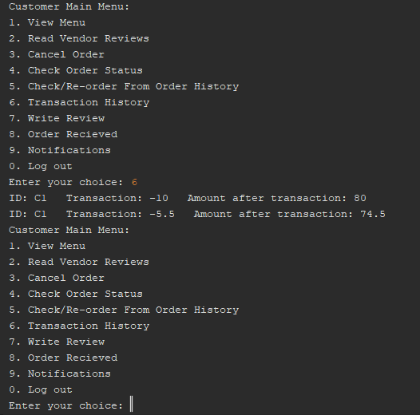

*Figure 3.3.7.1*

Entering option 6 will display the transaction history of the customer and return the customer back to the customer main menu.

### 3.3.8 Write Review

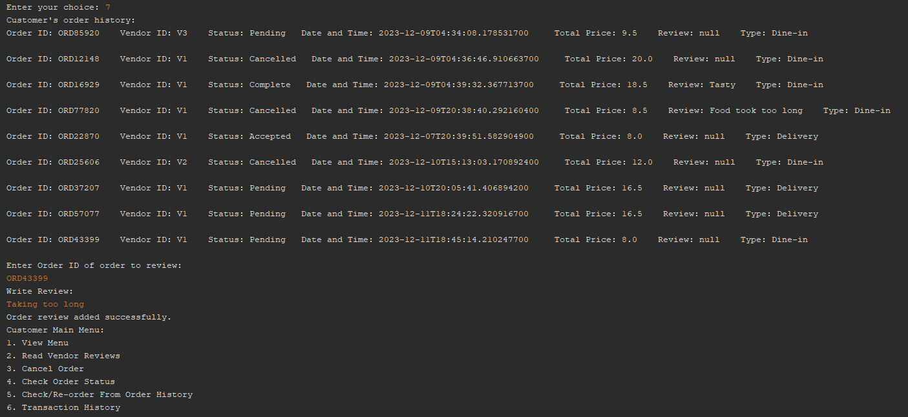

*Figure 3.3.8.1*

Entering option 7 will ask customer to enter Order ID of the order they wish to review, followed by the review writing. Once review is completed, it will let customer know that the review is added and redirect customer to customer main menu.

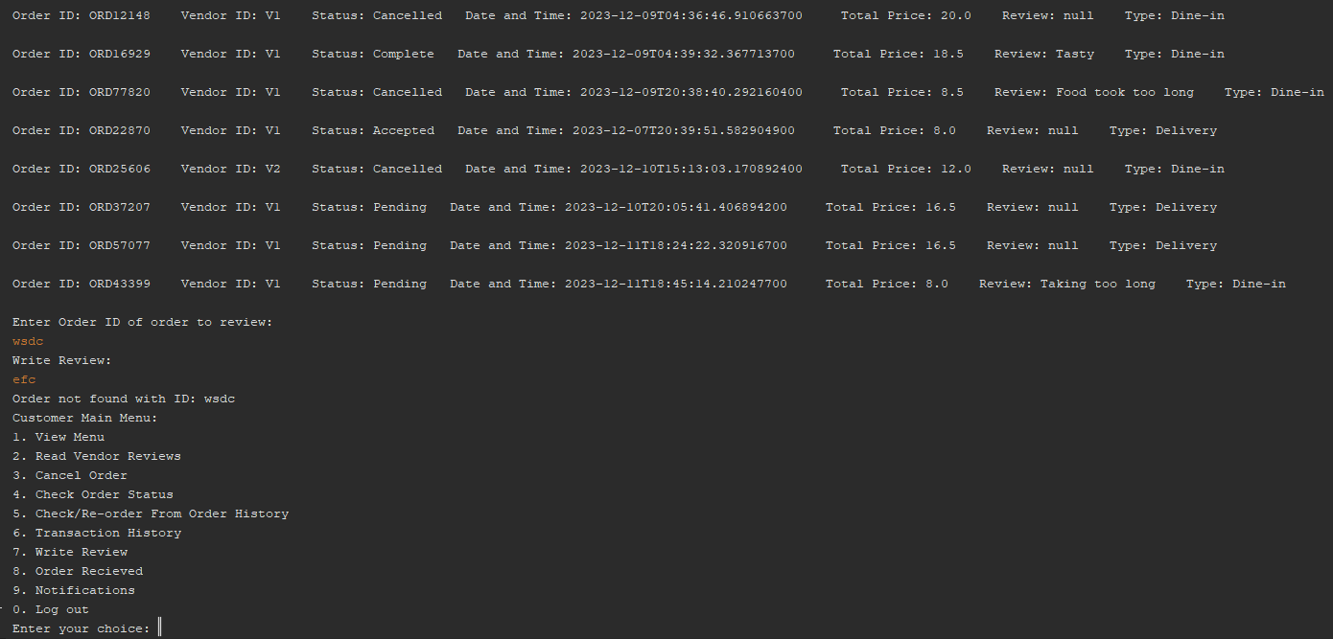

*Figure 3.3.8.2*

Entering an invalid Order ID will let customer know that Order ID not found and return customer to customer main menu.

### 3.3.9 Order Received

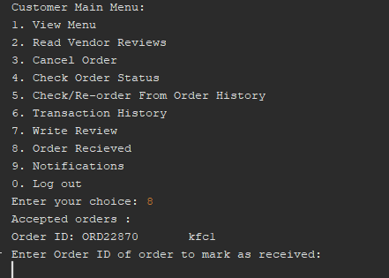

*Figure 3.3.9.1*

Entering option 8 will display all Accepted orders and ask users to enter Order ID to mark it as received. Accepted orders are only displayed as these are the orders that the vendor accepted.

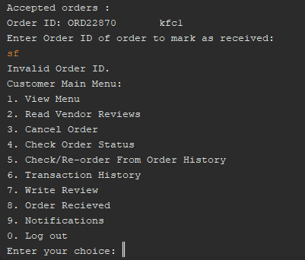

*Figure 3.3.9.2*

Entering an invalid Order ID will display “Invalid Order ID.” and return customer to the customer main menu

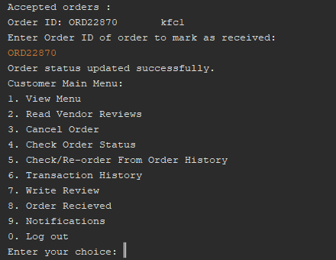

*Figure 3.3.9.3*

Entering a valid Order ID will let customer know that the order status has been updated and will be redirected back to the customer main menu.

### 3.3.10 Notifications

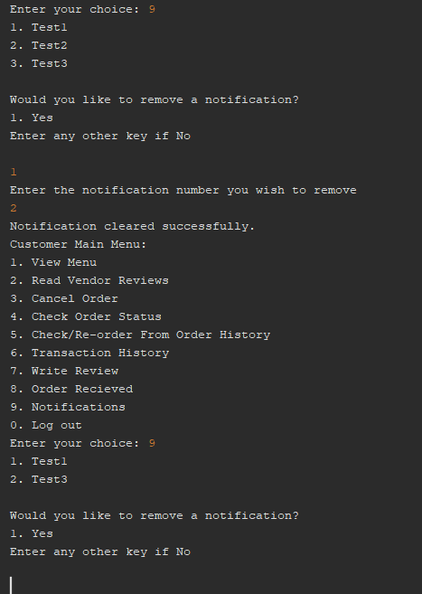

*Figure 3.3.10.1*

Entering option 9 will display all notifications of the customer in a numbered manner. Customer can choose whether they want to remove a notification or not. If Yes, customer will be asked to enter the notification number they wish to remove. Upon entry, message that the notification is cleared will be sent and customer will be sent to the customer main menu. If they go back to the notifications page, the notification that the customer just removed will be gone.

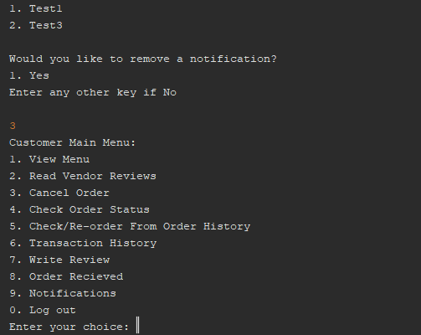

*Figure 3.3.10.2*

If customer wishes to leave without messing with the notifications, they can enter another number and they will be redirected to customer main menu.

### 3.3.11 Log out

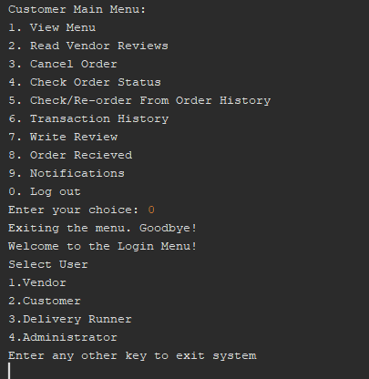

*Figure 3.3.11.1*

Entering option 0 will log the customer out and take them to the user selection and log in page.

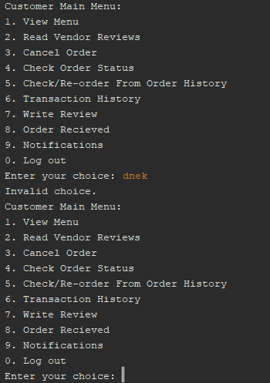

*Figure 3.3.11.2*

Entering an invalid choice for the customer main menu will display the message saying it is an invalid choice and display the customer main menu again.

## 3.4 Delivery Runner Part

The Runners.java class is a class used to store the details of all runners during the runtime of the program. These details include the runner’s id, password, name, and balance, as well as all their assigned, accepted, rejected, and completed delivery orders. The details of all runners are stored in an ArrayList of Runner objects from a Runners.txt file whenever the delivery functionality is called by the main program, and the details of all runners are updated immediately in the Runners.txt file whenever a change occurs during runtime.

The Delivery.java class is essentially a storehouse for all our methods dealing with the delivery of our ordered products. What this means is that all the functionalities of delivery are implemented in our main class using method callbacks of a Delivery object instantiated in the main class itself. This allows for our programmers responsible for coding the delivery features to be able to work in parallel with the rest of the team working on the features of other users without any team member’s work interrupting or hindering another’s.

Whenever a customer makes an order through the main java application, they are prompted to choose between delivery and dine-in. On choosing delivery, the method to assigns a rider at random is called, passing in that order’s generate unique orderId. The assignRunners method assigns the order to a runner at random, as long as they don’t have that orderId in their “declined orders” instance variable ArrayList. Once a runner is assigned an order, they can choose to either accept or reject this order. If an order is rejected, it is added to the runner’s “declined orders” ArrayList and the assignRunners method is called again, reassigning the order at random to another runner. The assignRunners method returns a false boolean value if no driver is assigned, allowing the main class to then prompt the user to choose a different order method.

Another important method in the Delivery class is the deliveryScreen, that takes in the runner’s ID as an argument. This method is called when a successful login is made through a runner account, and is used to display all the application functionalities available to the runners. Through this feature, runners are able to:

1. View tasks assigned to them and decide whether to accept or decline them.
2. View a list of their accepted tasks and choose to mark them as complete.
3. View a detailed history of their completed tasks.
4. View a revenue dashboard that shows their earnings for the past day, month, and year.

### 3.4.1 Delivery Runner Menu

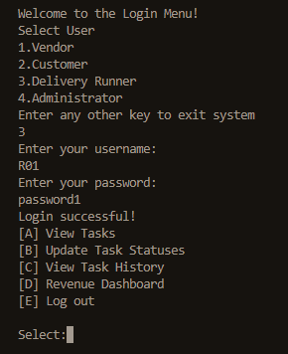

### 3.4.2 Available View Task & Accept Order

From the available task, we choose 9 number order to delivery. In the View Tasks menu, we are able to accept ORD25771.

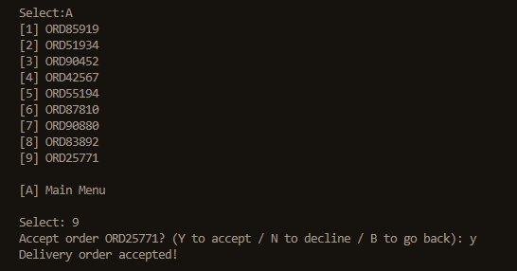

### 3.4.2 Update Task Status

Order 25771 is marked as complete and the delivery fees are added to the runner’s balance.

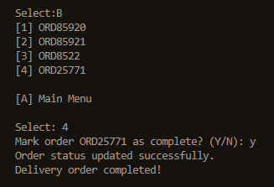

### 3.4.3 View Task History

Order 25771 can then be found in the task history menu

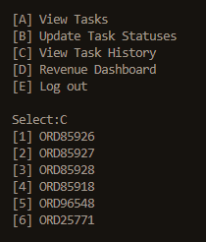

# 4.0 Description & Justification of OOP Concept

## 4.1 Encapsulation

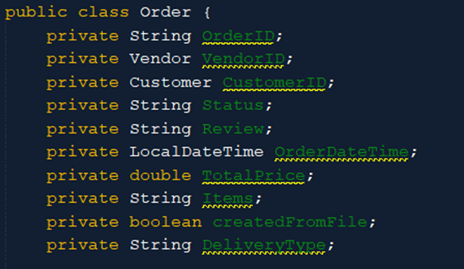

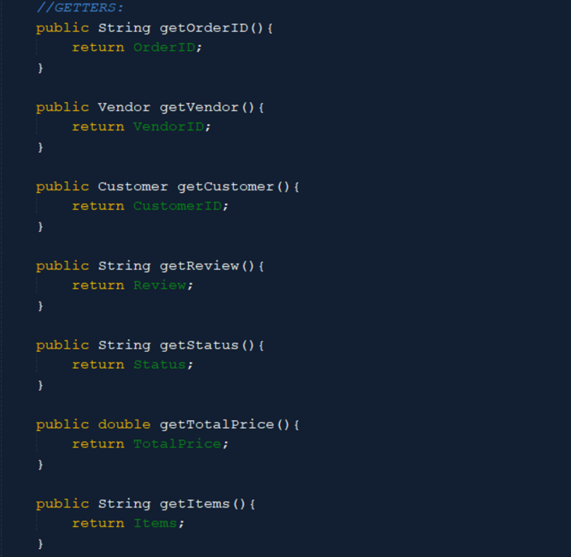

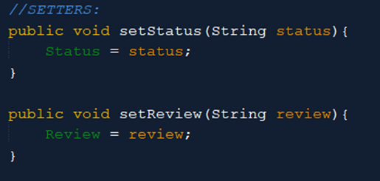

Encapsulation means bundling data and methods within a class and controlling access to them. Classes will have most attributes as private or protected. In order to access these attributes from another class to either get them or to set them to another value, encapsulation is necessary as you cannot directly access them.

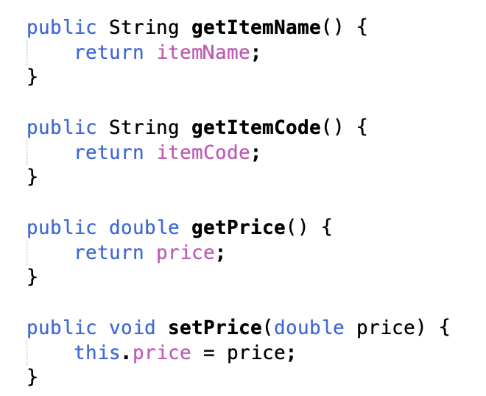

This is the getters and setters for Vendor which is encapsulation. Encapsulation means bundling or managing data and methods within a class controlling access to them. Classes will have most attributes as private or protected. In order to access these attributes from another class to either get them or to set them to another value, encapsulation is necessary as you cannot directly access them.

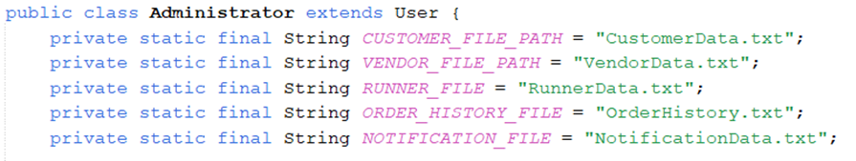



Encapsulation is another essential concept in Object-Oriented Programming (OOP), which refers to the process of merging data or attributes and functions into a single entity known as a class. Access to the class's data is managed through clearly defined interfaces, which are referred to as public methods. The implementation details and inner workings of the class are kept hidden from the public. The file paths (CUSTOMER_FILE_PATH, VENDOR_FILE_PATH, and so on) are declared as private static final properties by the class. To prevent those from outside the class from gaining direct access to them, they have been labelled as private. Due to the presence of the private keyword, these fields are only accessible within the “Administrator” class. Additionally, it is not possible for other classes to have direct access to them. As a result of the utilization of static, these fields have been elevated to the status of class-level variables; they are no longer instances of the class but rather incorporate themselves into the class itself. To ensure that their values cannot be changed once they have been initialized, the final keyword is put in place. Example public methods that provide access to these private characteristics include “addUserMenu” and is “UserIDExists”. Both of these methods are publicly available. The external state of the class can be accessed by these methods, which act as access points or interfaces. Class methods are responsible for providing the logic that is used to manipulate files and validate the existence of users. This provides the class with control over how these operations are carried out and guarantees that any alterations made to the implementation will not influence the external code that makes use of these method. One can benefit from encapsulation in several different ways is like disguised forms of information. The class can reduce the number of dependencies and make implementation modifications easier without affecting other software components if it conceals internal information from external classes. Examples of such information include file directories. Next, is controlled access. We can increase the likelihood that the manipulation of data will adhere to the anticipated logic by restricting access to the internal state or modifying it by public methods.

## 4.2 Inheritance

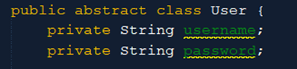

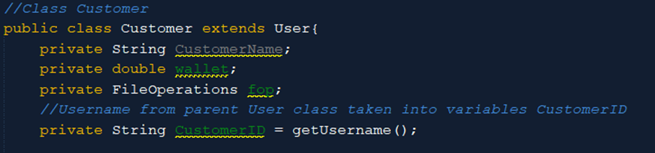

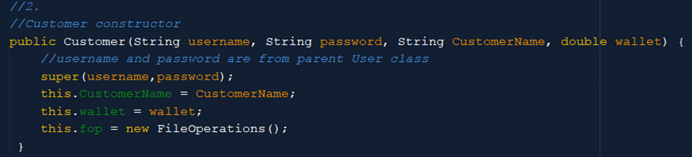

Inheritance allows a new class (called a subclass) to inherit attributes and methods from an existing class (called a superclass). This mechanism facilitates code reuse and the creation of a hierarchy of classes. In this code’s case, User class is the superclass and Customer is the subclass as it says Customer extends User. Since Customer is a subclass of User, Customer should contain the attributes of User, therefore the function super() is used to establish the connection between the two classes.

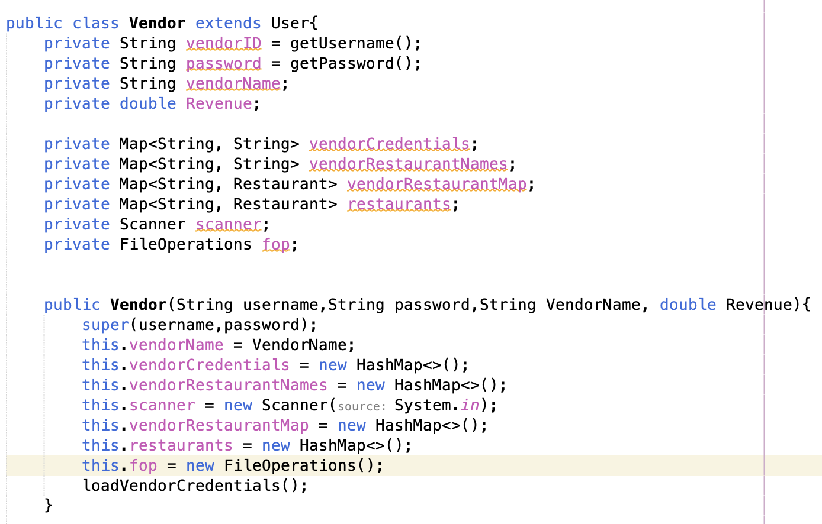

This is the Inheritance for Vendor. Inheritance is a concept that allows a new class (called a subclass or derived class) to inherit attributes and methods from an existing class (called a superclass or base class). This mechanism facilitates code reuse and the creation of a hierarchy of classes. In this code’s case, User class is the superclass and Customer is the subclass as it says Customer extends User. Since Customer is a subclass of User, Customer should contain the attributes of User, therefore the function super() is used to establish the connection between the two classes.





Both the "User" class and the "Administrator" class are extensions of one another. It is quite probable that the "User" class in the application possesses generic characteristics and behaviours that are shared by a variety of users working within the application. It might, for instance, have methods like "displayMenu()" and properties like "userID" and "password". The "Administrator" class extends from the "User" class, which indicates that it possesses additional or specialized capabilities that are exclusive to administrators, in addition to sharing characteristics that are common to users in general. This is an example of an "is-a" relationship, in which a "User" is analogous to a "Administrator" in a more concentrated form. It is the responsibility of the "User" class to give the "Administrator" class the methods and attributes that it inherits. In situations where "User" is comparable to a general employee, the term "Administrator" refers to a specific sort of employee that has additional obligations and powers (for example, the ability to manage other users). We may be able to promote the reuse of code and the establishment of organizational structure by utilizing inheritance to construct a hierarchy of classes that illustrates the connections that exist between the different types of entities that are present in our system.

## 4.3 Polymorphism

Polymorphism is a concept that allows objects of different types to be treated as objects of a common type. It enables a single interface to represent various types of objects and supports the idea that different classes can be used interchangeably if they adhere to a shared interface.

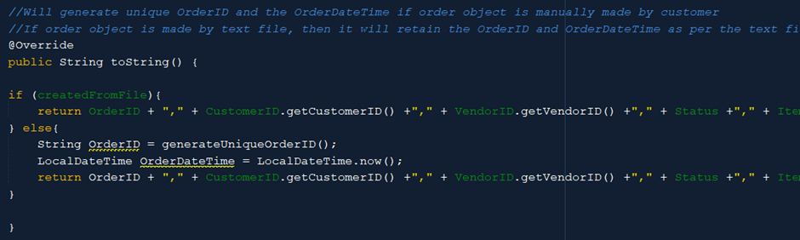

In this code, I used “@Override”, which is a specific form of polymorphism (run-time polymorphism). By overriding the toString() method, I provide a more meaningful representation of the order object to the OrderHistory.txt file

Polymorphism, in relation to method overloading, is a fundamental concept in object-oriented programming (OOP) that enables a single method name to reflect a variety of behaviours based on the type or quantity of the parameters that it takes. Techniques that fall under the category of method overloading include compile-time polymorphism, which is also known as static polymorphism. The “addUserMenu” method is experiencing an overload at the moment. This technique is available in two distinct forms, each of which has a unique collection of parameters:

**The first form:**



**The second form:**



Both of these methods have the same name, “addUserMenu”; however, the parameter lists for each of them are different. In contrast to the previous version, which does not provide options for user type, ID, name, password, and wallet balance, the second version makes these parameters available. The benefits of polymorphism, often known as method overloading, are as follows: The code is easier to comprehend as a result of method overloading, which gives method names that are descriptive of the many usage circumstances being considered. Furthermore, within the context of this particular scenario, it is apparent that the “addUserMenu” function is the one responsible for adding users, and the method signature details the parameters that are required. It makes it possible to develop a uniform user interface for jobs that are linked. Users of the class can consistently call the method, regardless of the specific parameters that are required. A method overloading situation within the addition of the name of the method can be used to suggest polymorphism if it is made possible for the “UserMenu” method to handle a variety of cases depending on the parameters that are provided. Not only does this improve the code's readability, but it also makes it more uniform and flexible.

## 4.4 Abstraction

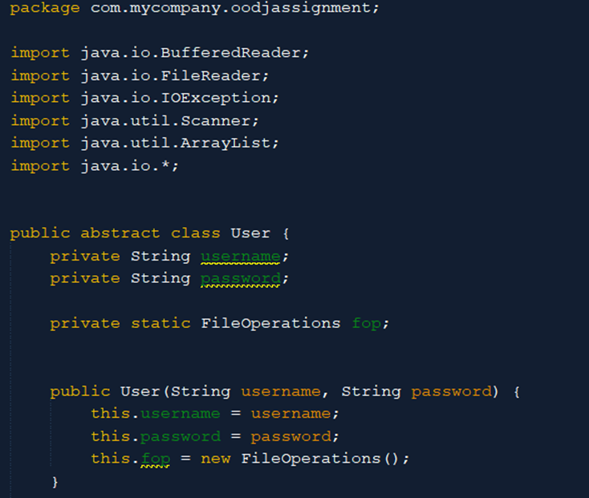

Creating a class as an abstract class serves the purpose of defining a common interface for its subclasses (Customer, Vendor, Administrator) and preventing the creation of objects directly from that class. An abstract class cannot be instantiated on its own. Instead, it is meant to be subclassed by other classes.

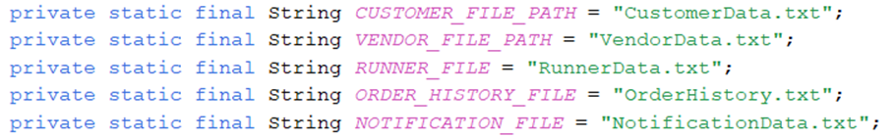

The main concept of abstraction in object-oriented programming is the simplification of complex systems through the modelling of classes according to the fundamental qualities and actions that they possess. The only components of the intricate reality that are shown are those that are vital and pertinent, while the remaining aspects are kept hidden. Private static final fields are used to specify the file paths, which are responsible for providing information about the location of the data. These fields include “CUSTOMER_FILE_PATH, VENDOR_FILE_PATH”, and others. Several methods, like “addUserMenu”, “readUserMenu”, “updateUserMenu”, and others, are used to abstract away the specifics of how files interact with one another. Users can do high-level activities (such as adding, reading, and updating users) without having to deal directly with the specifics of file input and output processes.

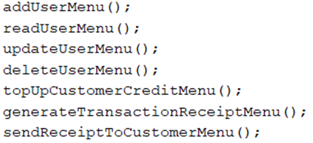

Managing different kinds of users, such as customers, vendors, and runners, is accomplished by the “Administrator” class through the utilization of methods such as “addUserMenu” that have overloaded parameter lists. The result of this is that users can add different types of users without being aware of the inner workings of how each type of user is handled. The addition of customers, vendors, and runners is possible without the users having to worry about the nuances involved in managing each type of user. The “Administrator” class provides a user interface that is less complicated than other user classes since it can abstract the differences between the various user classes.





## 4.5 ArrayList

Objects of the Array List class can be created and manipulated using object-oriented principles.

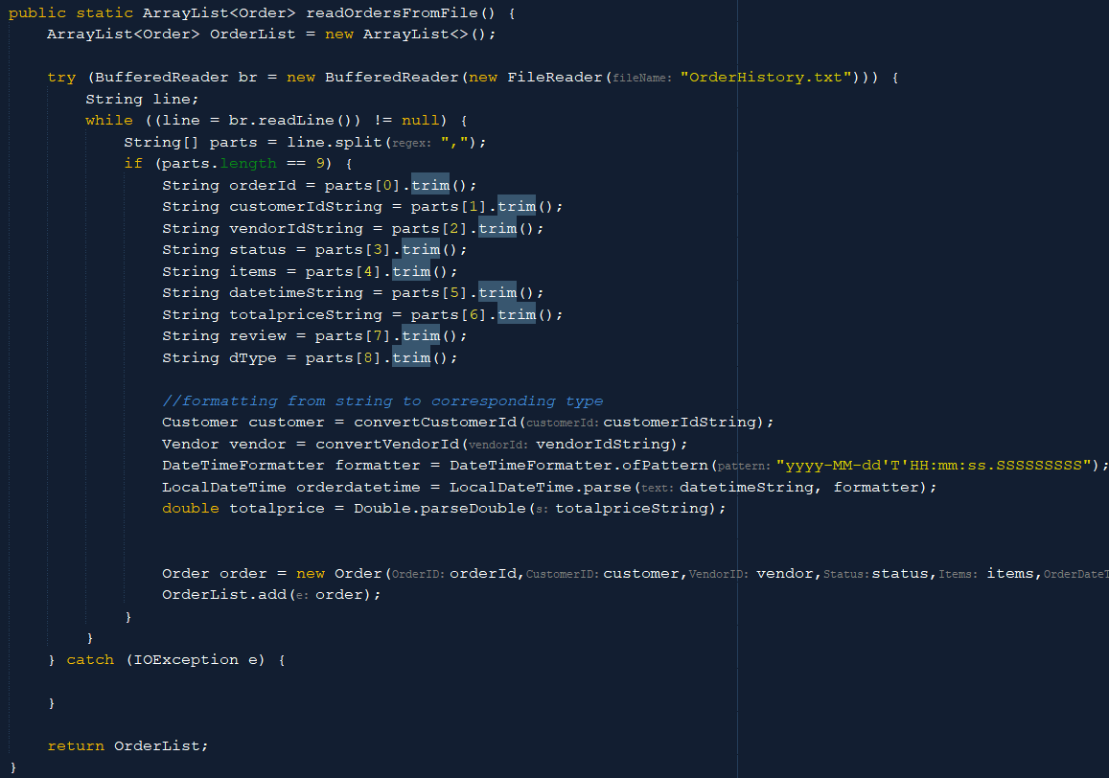

This is a method in the Order class that returns an ArrayList of all the orders from the OrderHistory.txt. In this method, an ArrayList with Order class by ArrayList<Order> function. The variable OrderList is defined with the said ArrayList. Order objects can be added to this variable with the OrderList.add(order object) function

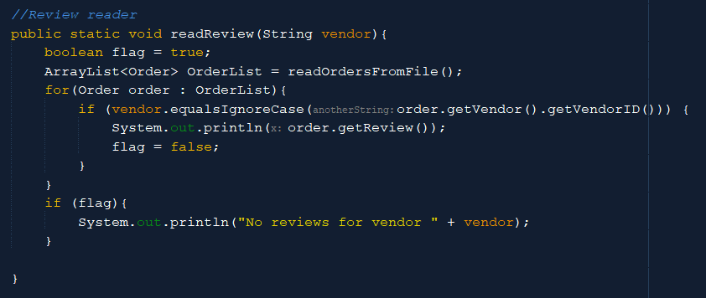

This is a method in the Order class that reads the review of a vendor. In this example, an ArrayList<Order> is created and defines the variable OrderList. This variable uses the function that is in the previous screenshot. After the definition, all the orders in the OrderList are being looped. It contains ‘order.getVendor().getVendorID()’ which means the order stored in the ArrayList<Order> can use all the methods of the Order class.

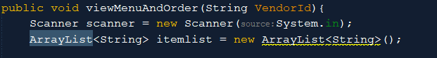

2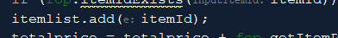

Another example of ArrayList is shown in the viewMenuAndOrder() function in the customer class. This creates an ArrayList<String> itemList which is an ArrayList that stores strings in a variable named itemlist. Strings can be appended to the itemlist with itemlist.add(‘string to add’)

## 4.6 Constructors

Constructors are one-of-a-kind methods that are responsible for initializing the state of an object when such an object is created. The constructors of a class are invoked whenever an instance of that class is instantiated. Typically, they are responsible for setting the initial values for the attributes of the object or doing other actions related to the setup process. In the “Administrator” class, there is a constructor that is as follows:

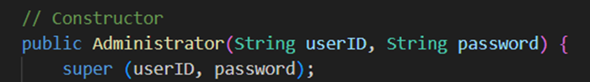

The constructor of the superclass, which is called “User”, is invoked by using the “super(userID, password)” constructor. Because the “Administrator” class extends the “User” class, this must be done because the “Administrator” class is responsible for initializing the state that it has inherited from the “User” class upon its creation. When we use the “super(userID, password)” function, we can call the constructor of the “User” class by providing the “userID” and password as arguments. By carrying out this action, it is guaranteed that the “Administrator” class will have the common attributes or actions that are defined in the “User” class populated appropriately. Before the constructors of the subclasses are called, the constructors of the superclass are called. In this particular case, the constructor of the “User” class is invoked first, and then the constructor of the “Administrator” class is invoked after that. According to the hierarchy of classes, this is applicable. The first statement that the constructor must make is the call to the “super(userID, password)” function. Specifically, it ensures that the constructor of the superclass is executed before any additional initialization code in the subclass could be executed.

# 5.0 Limitation & Conclusion

To summarize, the application for ordering meals on campus is an excellent effort to enhance the user experience inside a technologically savvy educational setting. By bringing together cafeteria suppliers, customers, runners, and administrators on a single digital platform, the program intends to improve the efficiency of meal ordering, transactions, and user-specific capabilities.

In order to achieve its goal of establishing new benchmarks for campus services, it places a significant emphasis on user-friendly design and vast feature sets. The documentation that is included with the application serves as a comprehensive guide, elaborating on the ways in which object-oriented programming principles serve as the foundation for the application.

It is important to note that the program does have some limitations. Potential obstacles could include those related to technology, which would depend on the infrastructure of the organization; the requirement for broad user adoption, which could be hampered by reluctance to change or a lack of awareness; the necessity of strong security measures because of sensitive transactions; possible difficulties in coordinating with stakeholders; and the crucial factor of scalability in order to support an expanding user base. Despite the fact that the program has a great deal of promise, these problems need to be fixed in order to guarantee that it will be successfully implemented and will have an effect that will carry on for a long time. In order to address this issue, it is necessary to implement regular updates, educate users, and take preventative measures.

# References

*OOPs concepts in Java With Examples* (2023) *Great Learning*. Available at: <https://www.mygreatlearning.com/blog/oops-concepts-in-java/>.

# Workload Matrix:

## Documentation

|  |  |  |  |  |
| --- | --- | --- | --- | --- |
| Task Component | Mohammad Abu Huzaifa  TP070586 | Mohamed Zeek Shujau TP071203 | Janani A/P Munaindy  TP066035 | Khaled Fostok  TP071202 |
| ABSTRACT | 100% | 0% | 0% | 0% |
| Introduction | 100% | 0% | 0% | 0% |
| Design Solution | 100% | 0% | 0% | 0% |
| Screenshot of Code Output | | | | |
| Administrator | 0% | 0% | 100% | 0% |
| Vendor | 100% | 0% | 0% | 0% |
| Customer | 0% | 100% | 0% | 0% |
| Delivery Runner | 0% | 0% | 0% | 100% |
| Justification of OOP Concept | 20% | 60% | 20% | 0% |
| Limitations & Conclusion | 0% | 0% | 100% | 0% |

## Code

|  |  |  |  |  |
| --- | --- | --- | --- | --- |
| Task Component | Mohammad Abu Huzaifa  TP070586 | Mohamed Zeek Shujau TP071203 | Janani A/P Munaindy  TP066035 | Khaled Fostok  TP071202 |
| User Class | 0% | 100% | 0% | 0% |
| Administrator Class | 0% | 0% | 100% | 0% |
| Vendor Class | 100% | 0% | 0% | 0% |
| Customer Class | 0% | 100% | 0% | 0% |
| Delivery Class | 0% | 0% | 0% | 100% |
| Runner Class | 0% | 0% | 0% | 100% |
| Order Class | 0% | 100% | 0% | 0% |
| FileOperations Class | 50% | 50% | 0% | 0% |

## Screenshot of all Text Files

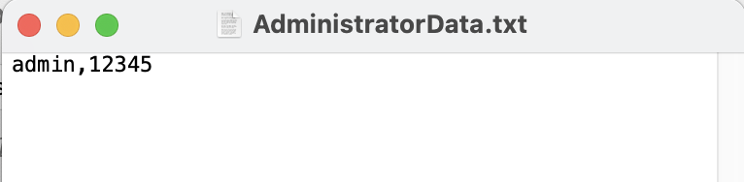

*Figure: Text File of AdministratoDatar.txt*

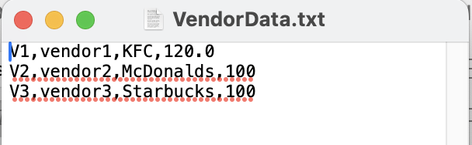

*Figure: Text File of VendorData.txt*

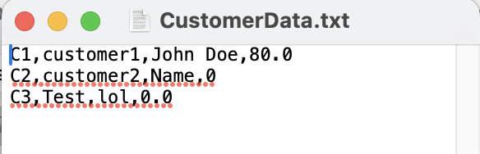

*Figure: Text File of CustomerData.txt*

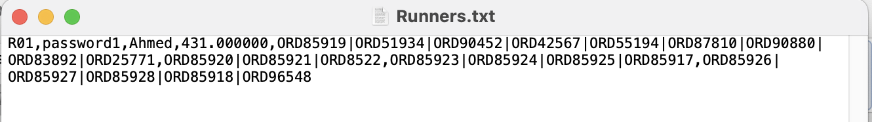

*Figure: Text File of Runners.txt*

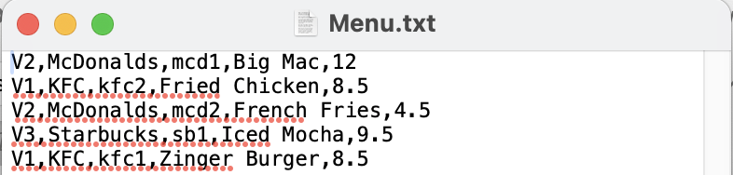

*Figure: Text File of Menu.txt*

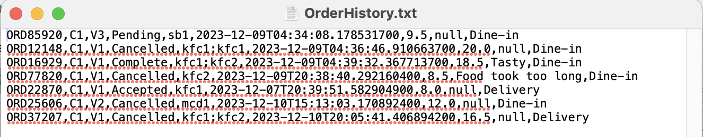

*Figure: Text File of OrderHistory.txt*

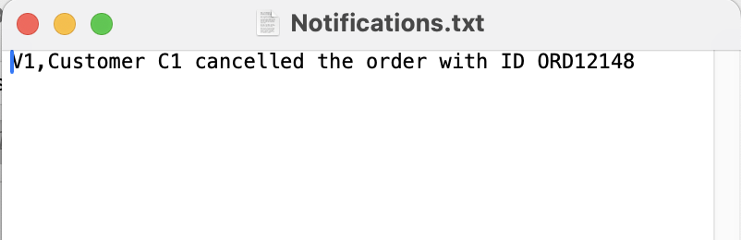

*Figure: Text File of Notifications.txt*

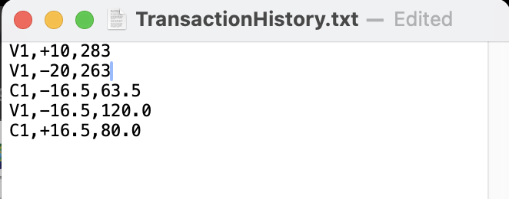

*Figure: Text File of TransactionHistory.txt*